Tweeting about Women’s Rights

and the 2016 Presidential Election

*By* Ling Bai (lb2921) and Amanda Gates (arg2211)*

# 

* Bai (lb2921@columbia.edu) and Gates (arg2211@columbia.edu). Quantitative Methods in the Social Science, Columbia University in the City of New York, International Affairs Building, MC3355, 420 W 118th St, Suite 807, New York, NY 10027.

# I. Introduction and Literature Review

How are current events reflected in tweets? We set out to investigate this question by concentrating on the juncture of tweeting about presidential candidates and tweeting about women’s rights. Topics related to women’s rights and gender equality are commonly talked about in American politics, especially during elections. By using a number of sources such as online articles, women’s rights organization websites, and presidential candidate websites, we chose to focus on six main subjects that fall under the women’s rights umbrella; these include reproductive rights, violence against women, professional inequalities, men’s roles, intersectionality, and general feminism (American Psychological Association, Task Force on the Sexualization of Girls, 2007; National Organization for Women, n.d.). These six topics, we feel, are representative of many conversations surrounding women’s rights in the current presidential election.

The reproductive rights category covers discussions about abortions, birth control, contraception, menstruation, and other forms of access to women’s healthcare. The state of reproductive rights for women is less-than-ideal in America. The Center for Reproductive Rights – an organization dedicated to using the law to provide reproductive rights to all women – provides a good outline of the current state of affairs for this topic (Center for Reproductive Rights, 2015). There are many places in the United States that make it very difficult for women to get access to reproductive healthcare, such as abortions, birth control, and contraception (Center for Reproductive Rights, 2015). In addition to healthcare-related issues, there is also a lot stigma surrounding menstruation and pregnancy (Crawford & Unger, 2004). Women are often shamed for bodily functions that are natural, such as menstruation (Crawford & Unger, 2004). We used words related to these topics to capture tweets that discussed various kinds of reproductive rights.

Violence against women encompasses many issues, such as sexual violence, rape culture, domestic abuse, and human trafficking. The World Health Organization states that these violent acts against women “are major public health problems and violations of women's human rights” (WHO Media Centre, 2016). About 35% of women worldwide have experience sexual violence from a non-partner or sexual or non-sexual violence from a partner. That is a staggering statistic. This kind of violence has very negative effects on women; it “can negatively affect women’s physical, mental, sexual and reproductive health, and may increase vulnerability to HIV” (WHO Media Centre, 2016). We used words and phrases related to all kinds of violence against women to examine how people talk about this topic related to the election.

Professional inequalities cover such topics as the pay gap between genders, underrepresentation of women in fields such as politics and sciences, and family leave policies at places of employment. The World Economic Forum (2015) gives the United States a “C” grade on its amount of gender equality based on factors like economic participation and opportunity, educational attainment, health and survival, and political empowerment. More women than men enroll in tertiary education (college) in the U.S. but make up less than half of the labor force (World Economic Forum, 2015). The female-to-male ratio for political presence is dismal at 23% (World Economic Forum, 2015). Many tweets mentioned issues related to professional equality.

Men play a large role in women’s rights, so this category relates specifically to men. Topics such as misogyny, meninism, patriarchy, and hegemonic masculinity are included in this category. Misogyny, or the hatred of women, unfortunately exists in the United States (and in many other countries around the world). The United States has a strong history of patriarchy, which is evidenced in the gender of American leaders and policy-makers (Crawford & Unger, 2004). Masculinity and traditional gender roles play a part in enforcing gender inequality through social power structures (Crawford & Unger, 2004). We aimed to examine conversations about similar theories in tweets about the current election.

Of late, rhetoric about feminism and women’s rights has been criticized for its lack of inclusion of minority voices and experiences (Vidal, 2014). Historically, women’s rights movements have focused on the experiences of white, middle-to-upper-class, cis-gender, able-bodied women, but many kinds of women exist in the world (Crawford & Unger, 2004; Vidal, 2014). It is important to include all women in the fight for women’s rights. The category about intersectionality aims to capture these conversations. Conversations about women of color, differently-abled women, and women of all sexualities are included in this category.

Lastly, the category about feminism encapsulates discussions about feminist ideas, people as feminists, gender roles, general sexism, the sexualization of women, and expectations of women. Feminism is generally described as the view that women are valuable and societal factors need to change to represent this view (Crawford & Unger, 2004). There are many kinds of feminism and countless theories, some of which conflict with one another, but the core idea remains stable throughout all kinds of feminism: that women are worthy of respect and deserve the same rights as men. Feminists want to end sexist oppression of women, which takes many forms. Women (and men) are judged based on their sexual choices, their parenting abilities, the way they dress, how they express emotions, and so much more. We wanted to collect tweets that discuss things related to these topics, as well.

The final four Democratic and Republican presidential candidates all have their own stances on women’s rights. Both of the Democratic candidates have similar views about women’s rights and support gender equality. According to Clinton’s official campaign website, she will “ensure equal pay for women, defend women’s health and reproductive rights against attacks, and fight for paid family leave and affordable child care,” among many other things (Hillary for America, 2015). Clinton identifies as a feminist and wants to take actions that will increase equality between men and women. Sanders also identifies as a feminist and has similar ideologies to Clinton. According to his campaign website, he will “fight for pay equity for women, expand and protect the reproductive rights of women, only nominate Supreme Court justices who support Roe v. Wade and the reproductive rights of women, make quality childcare and pre-k available to all Americans,” and wants to install many other policies (Bernie 2016, 2015).

The two Republican candidates differ in their opinions about women’s rights and have more conservative views. Cruz does not identify as a feminist and does not support many women’s rights initiatives. He holds traditional views on marriage and is pro-life when it comes to abortion (Cruz for President, 2015). Cruz does not support Planned Parenthood and its mission to provide access to healthcare and a woman’s right to choose. Trump does not mention anything about women’s rights on his campaign website (Donald J. Trump for President, Inc., 2015). He has a video titled, “Political Correctness” which features him saying that “being politically correct takes too much time” (Donald J. Trump for President, Inc., 2015). He is probably referring to all of the social justice initiatives that want to stop generalizations of and prejudice against minority groups. Women are considered a minority group, so Trump is effectively saying that he does not support or care about women’ rights. We will return to the connection between candidates’ stances and how people tweet about them later.

# II. Data and Methodology

## A. About the Data

The data used in the current study are tweets collected daily from the Twitter API from February 7, 2016 to April 30, 2016. Dr. Navid Hassanpour and Daniel Kronovet coordinated the gathering of this data and made them available to us as JavaScript Object Notation (JSON) and comma separated value (CSV) files. The entire data set from each day was down-sampled to about 1% so the file sizes would not be large to work with on laptops with average computing abilities (Kronovet, 2016). All of the visualizations we created to represent these data use the summary CSV files to ensure that our data visualization process was more efficient and effective.

We manipulated the data in various ways so they would have appropriate formatting for each visualization. We utilized tweet parsing, text mining, subsetting, regular expressions, and numerous other techniques to do this. Next, we outline the methods we used to format the data and to then create all of the visualizations for this project.

## B. Data Manipulation

For all of the visualizations we created, we used multiple combinations of variables but had to perform a few key tasks first. We downloaded all of the summary CSV files within the desired date range (February 7, 2016 to April 30, 2016) and loaded them into R as data frames. We combined all of the daily data frames together by month first, ending up with large data frames for February, March, and April. Then, we subset these and kept a handful of columns that we knew we would need later.

For each monthly data frame, we created subsets for each candidate by using a regular expression (regex) function to capture tweets that had certain phrases in them. For all of the candidates, we chose to use their first and last names as well as any Twitter hashtags that were associated specifically for their campaign. For example, #MakeAmericaGreatAgain is Trump’s campaign slogan so we included that in his regex function. For Sanders, we included #FeeltheBern and, for Clinton, we included #ImWithHer, #HillYes, #GiveEmHill, #ShesWithUs, and #HRC. We researched these hashtags on Twitter and used various articles to determine which phrases would catch the tweets we wanted. Choosing to create different subsets for each candidate allowed us to assign tweets to more than one candidate if they mentioned more than one. Then, we combined the three monthly subsets for each candidate into one data frame per candidate.

The next step was to label tweets by the six topics we defined earlier: professional gap, reproductive rights, violence against women, men’s role, intersectionality, and feminism. We used a similar regex function to assign topics to each tweet and discarded any tweets that did not mention one of our six topics. We researched popular Twitter hashtags relating to these subjects and read recent articles (written in the past three years) to come up with small dictionaries of words and phrases that would identify what topic a tweet discussed (Chan, 2014; Howard, 2015; Hunt, 2015; Long, 2014; McPherson, 2014; Noman, 2015; Northup, 2013; Plank, 2014; Pressman Fuentes, 2014).

We manipulated the candidate, topic, date, user location, and Twitter handle variables by counting them, subsetting them, and using them to create new variables for different parts of this project. These original variables were the foundation for our visualizations, which we will outline next. All the visualizations we created for this project are housed in an [R Shiny app](https://arg2211.shinyapps.io/DataVizFinal/); we used a combination of R, D3, and Google Maps to make everything.

## 

## C. D3 Time Series Visualizations

Since we want to show how each candidate’s topic trend along with time (February 7th to April 30th), we decided to use several different d3 plots to have a better visualization effect.

### *Multi-Series Line Chart*.— We'll start with the multi-series line chart and look at how it gets generated. Then, with that as a baseline, we can compare that process with that used for the other three chart types. A multi-series line chart is a set of path elements representing lines in a graph. In this case, we wanted to make a line for each of the data columns representing the six different topics (feminism, men, reproductive rights, professional gap, intersectionality, and violence against women), so we have a total of six path elements.

To start, the data is loaded from a CSV file and then we need to do a little bit of data manipulation to get the data set up to be passed to D3 to render the SVG paths. We are appending a "g" element (the "g" element allows us to group other items like a text label if we want to do so later) to each series and then passing its "values" array to "line". Then we assigned the labels on the x-axis as “date” to correspond the column name on the CSV file. This way, we could ensure we could observe the topic trend on our plots. Next, we rendered the lines in D3 by setting the attribute of the SVG as a line plot.

### *Streamgraph.*— Now we will take a look at bare bones example of a streamgraph. It has only the code needed to create a basic visualization without any potentially distracting code for more customizable aspects like axes and legends.

Like the multi-series line chart, the streamgraph is made up of paths for each of the series in the data. Instead of drawing lines, the paths create an irregular shape that fills the area taken up by the series. The larger the area, the more tweets fall into that topical category. To draw the paths, we make use of the *D3.layout.stack()* and *D3.svg.area()* tools.

After doing the above, most parts are the same as that of the multi-series line chart. Each series gets a "g" element and a path is appended that represents the data series. D3 is again doing all the hard work generating the path information. We just need to send the "values" array to "area" in the code.

*Area* is one of D3's many SVG shape generators. Here, we set up *D3.svg.area()* with a few lines of code. In the first line, the interpolation will define the way the SVG path looks, which can be altered to produce other effects. In this case, we want to use *cardinal* to give the streamgraph the smooth, rounded look like typically seen in these kinds of charts. The other lines added to the *D3.svg.area()* code above are the accessories. We have to tell *D3.svg.area()* how to find the *x*, *y0* (bottom) and *y1* (top) of each element in the array. We can now see how the values inserted by *stack* above are used to layout the SVG path.

### *Stacked Area Chart*.— For the stacked area chart, all the code is same as the streamgraph code; the only difference is that we change *.interpolate("cardinal")* to *.offset(“zero”)*. This small alteration creates a smooth, horizontal base line for the plotted area along the x axis. The area only expands upwards vertically to reflect the y values (number of tweets) instead of allowing the area to expand vertically upwards and downwards like in the streamgraph.

### *Stacked Bar Chart*.— For the stacked bar chart, each column is a group of SVG rectangle elements. The processing of the data for this is quite a bit different than the previous plots, but the same basic steps for building the chart are used: (1) derive an array of the variable names that represent the series in the data file, (2) transform the data using the *varNames* array into the input D3 needs to lay out the chart, and (3) use D3 to create the SVG elements.

Similar to the processes we have already seen, the first step is to make the *varNames* arrays with all of the variables names that will be made into series. The code is exactly the same as before. We now have a list of variable names we can iterate over when processing the data.

We want to highlight one important point about what happens here: in the other charts we added a *g* element for each of the series, whereas here we make a *g* element for each row in the data and then iterate it over *mapping* to create the column of rectangles at point A. This can be a bit tricky, but we found iterating over a nested structure to be a powerful way to use D3. At point A, we call the data again and create a new subsetted dataset to iterate over. In this context, we are already cycling over the records to call data with *function(d) { return d.mapping; }*, which will return the mapping array for the record currently being edited.

### *Adding Legends, Axes and Tool-Tips*.—

#### **Adding Legends:** The code for adding the legends is exactly the same for all four D3 charts. We make use of the *varNames* array and then add legends to the charts.

#### **Adding Axes:** Again, to add the x and y axes, we use the same code across all four chart types. First, adding the axes requires a couple of new variables at the top of each file. Then, we draw the real axes on the plot.

#### **Adding Tool-Tips:** Tool-tips refers to the features associated with hovering the mouse over certain parts of the charts. For the tool-tips over the data points, we add both *Bootstrap* and *JQuery* to the files. You will see a *bootstrap.css* file added at the top as well as *bootstrap.js* and *jquery.js* added in script tags in each file. This can be done using a number of different JavaScript libraries (or none at all, really), but we preferred to use *Bootstrap* because the *Popovers* were more aesthetically pleasing to us and we found it to be relatively simple to use. With the CSS file and JavaScript files in place, we basically just add *removePopovers* and *showPopover* these two functions to each file.

With this in place, we were able to reference these functions in the appropriate places in the code. For example, in the multi-series line chart, a set of circles was added to each data point for the user to mouse over. We set up the event handlers on the circle elements by using *mouseover* and *mouseout*.

### *Putting it All Together*.— Combining all the code together produced a *chart.js* file loading along with the *D3.js*, *jquery.js*, and *bootstrap.js* files. The *chart.js* essentially takes the code from each of the four chart types and makes them into functions that can be called. It also adds a new function *onResize* that makes the size of the chart proportional to the size of the user’s browser. A *VIZ* object is returned from *chart.js* that has all the main functions (methods) that were needed to make the interactive chart. With the new *chart.js* file in place, the HTML file for the example needs only a few lines in it that call the necessary CSV files for the fours plots.

### You can view the hosted D3 visualizations in the [Shiny app](https://arg2211.shinyapps.io/DataVizFinal/) via the “Tweet Volume” > “Daily Counts by Topic” tabs or by clicking on their respective links here: for [Clinton](http://bl.ocks.org/LingBai/raw/087ed1939f58e300733735a6d47eac33/), for [Cruz](http://bl.ocks.org/LingBai/raw/afb82768327672f16baf74c4fbdc8307/), for [Sanders](http://bl.ocks.org/LingBai/raw/843668391a4517e2f585e5c705758864/), and for [Trump](http://bl.ocks.org/LingBai/raw/a271925e87c53da95cbd5b6651a6347d/).

## 

## D. Sentiment Analysis & Word Clouds

Sentiment analysis is often used to quantify users’ or consumers’ feelings about online products or services. The input could be anything from user reviews on Amazon or Google to tweets about particular products or companies. Sentiment analysis can also be used to measure, and even predict, public opinion about political candidates, markets, or brands. The input for these analyses could be tweets or web search terms, for example. The output of sentiment analysis ranges from a simple binary measure (positive vs. negative sentiment), to complex, multidimensional measures of affect and attitude.

In the current project, we utilize a continuous measure of valence; this measures how certain words make people feel and assigns numerical values based on the positivity or negativity of their reactions. The valence measures used in this project are available from a large database of human ratings (Warriner, Kuperman, & Brysbaert, 2013). In this project, we use the R program to perform a sentiment analysis of our Twitter data. Sentiment analysis is part of a broader set of tools available in the realm of natural language processing (NLP).

The sentiment analysis process begins with gathering text data; in the current study, this is the text from the tweets about each candidate. We used the same CSV files to filter tweets by the six outlined women’s rights topics and by the final four presidential candidates. First, we tokenized the tweets. One way to go about this is to use the “tm” package, a comprehensive text mining framework for R. First, we create a corpus from the tweets. A corpus is simply a collection of text documents.

Now, we tokenize the raw text into units. Although there are ways to assess the sentiment of phrases and sentences, we will use individual words as the unit of analysis. Using R base functions, we first converted the tweet text into the ASCII scheme and then made all of the text lowercase. We proceeded to clean the corpus by removing stopwords, which are some of the most common words in English (e.g., you, me, my, the). It is common to remove stopwords in text mining because they often do not add anything to sentiment analysis. Next, we removed strings that start with URL indicators using a function. We also did not need any numbers, punctuation marks, or extra white space in the corpus; we used the “tm” package’s functions to complete these tasks. The final step we took was to convert the cleaned text back to a character vector, attach it to the original data frame, and remove the original “text” column.

Once the pre-processing was complete, we first made word clouds for each candidate by topic (totaling 24 word clouds). The purpose of the word clouds in the current project is to visualize the most frequently-used words in the corpus. Since the size of the words reflects their frequency, we removed the dictionary words from each tweet first, otherwise these terms would dominate the word clouds. You can view the word clouds under the “Word Cloud” tab in the [Shiny app](https://arg2211.shinyapps.io/DataVizFinal/).

Next is the real sentiment analysis part. There are several large lexicons containing valenced (good/bad) word measures. We downloaded the affective ratings for English from Marc Brysbaert's research group at Ghent University, which contains about 14,000 English words (Warriner, Kuperman, & Brysbaert, 2013).

First, we retain valenced words with ratings towards either pole of the 9-point valence rating scale. That is, words that people rated as making them feel at least somewhat positively or negatively. We chose to eliminate any words that received a score between four and six since a rating of five indicates neutrality towards that word. We define a function that computes the mean and standard deviation of valence for all tweets about a given topic, on a given day. This function finds the mean score for each tweet by adding of all the valence scores and dividing by the total number of valenced words within each tweet. Thus, a mean, or overall, sentiment score is calculated for each tweet.

We examined the distribution of sentiment scores for tweets mentioning each of the four candidates and each of the six topics by creating bar charts. The bar charts convey the disparities in the number of tweets that have various mean sentiment scores. This allows users to see which topics (and which candidates) are talked about with the greatest amount of emotion. You can view these plots by clicking on the “Tweet Sentiment” > “Mean Scores by Tweet Count and Topic” tabs in the [Shiny app](https://arg2211.shinyapps.io/DataVizFinal/).

In addition to looking at sentiment scores by topic and candidate, we also wanted to delve further into the details of the data by splitting it up by days. We made line plots to visualize this data and see if the sentiment of the tweets varied day to day. You can view these plots by clicking on the “Tweet Sentiment” > “Mean Scores by Day and Topic” tabs in the [Shiny app](https://arg2211.shinyapps.io/DataVizFinal/).

## E. Mapping Geospatial Information

### *Sentiment Score Maps*.— Next, we wanted to explore how sentiment varies geographically. We first needed to make the continuous mean sentiment variable into a categorical variable to make plotting the scores simpler. A new variable was created that had six bins where the lowest evoked more negative emotions and the highest evoked more positive emotions.

The sentiment score maps, created via the “ggmap” package, show the location of every tweet whose author had geolocation abilities enabled. We used the *place_lon* and *place_lat* variables, which give the coordinates of the Twitter user’s “home” location, instead of the *lon* and *lat* variables, which give the coordinates of the Twitter user’s location when they posted the tweet. We chose to use the “home” coordinates because many more Twitter users enabled this geolocation service than their precise tweeting location.

We focused on locations within the United States since Twitter users who list their “home” location within this nation likely reside here. The opinions of those who reside here are probably more relevant than those who live outside the country. Thus, the base map is a black and white rendering of the United States.

The location of each data point, or tweet, is represented by a colored dot. The color of the dot indicates the tweet’s mean sentiment score. Lighter colors on the scale designate more negative emotion in the tweet while darker colors on the scale designate more positive emotions in the tweet. Each candidate has their own color, which is a theme continued throughout the whole Shiny app. You can reach these maps by clicking on the “Geolocated Tweets” tab in the Shiny app and then the “Mapped Sentiment Scores” sub-tab.

### *Tweets in Google Maps*. — In addition to mapping the locations of various emotions related to women’s rights and the election, we also wanted to give users a general sense of what geographical areas talk about each topic and each candidate. We followed a very well-written tutorial on how to use data with coordinates to create a personalized Google Maps rendering (Google Developers, 2016). This first involved importing our data sets into the application with some JavaScript code and the Google Maps JavaScript API. Next, we added markers whose shape varies by candidate and whose color varies by topic. Each marker is located on the exact ­*place_lon* and *place_lat* coordinates given with each tweet. We also edited the names of each section to make it easier to read and more aesthetically pleasing to the eye. You can reach the Google Maps page directly by clicking [here](https://drive.google.com/open?id=1hWfXZ1OSb7SHFK4dorw_57Qvmto&usp=sharing) or by clicking on the “Geolocated Tweets” tab in the Shiny app and then the “Google Maps” sub-tab.

## F. R Shiny App

In order to make our final product more cohesive and simple to use, we housed all of the visualizations in an R Shiny app. We used the *navbarPanel* UI layout to create various tabs that organize the visualizations by their purpose. The “About” tab gives an overview of the project’s main objectives, the “Tweet Volume” tab contains ggplot and D3 visualizations depicting changes in tweet counts, the “Word Clouds” tab contains all of the word clouds, the “Tweet Sentiment” tab contains renderings of sentiment analysis, and the “Geolocated Tweets” tab houses the tweets mapped through R and Google Maps.

We wanted to add different kinds of interactivity to the project. The option to choose different tabs and sub-tabs was our first step in this direction. Within the tab pages, we used drop-down menus and radio buttons to allow users to change the visualizations they see based on the candidate and/or topic. The D3 visualizations are hosted on bl.ocks.org, so links to these pages are listed on one of the app pages. We also added the link to the Google Maps page in one of the tabs.

Because we used so many different data sets to create all of our visualizations, we could not upload all of them to R Shiny as there would not be enough storage space. We decided to work around this problem by only uploading four small data sets for the “Tweet Volume” > “Total Counts by Topic” tab. All of the other interactive visualizations that can be viewed and changed directly on the Shiny app are PNG images. We created the plots in R and exported them as PNG images that could be rendered in the app; they looks exactly the same as the plots that are created directly from data sets but take up much less space. The smaller file sizes allowed us to use the free version of shinyapps.io to host our Shiny app online and upload all of the necessary files with it. Now, everything is neatly contained in [one place](https://arg2211.shinyapps.io/DataVizFinal/) with the same functionality and requires less processing power to run.

# III. Discussion and Interpretations of Visualizations

The main goal of this project is to visualize patterns in tweets about the final four presidential candidates and women’s rights. We looked for unique patterns in the data and sought out potential explanations for them in real-life events. We did this by reviewing online news articles, Twitter posts, and other sources that describe recent current events related to the 2016 presidential election. There are too many spikes and dips in tweet volume and interesting patterns in sentiment analysis and geo-located tweets to talk about, so we examine a few key events and patterns by which we were fascinated.

## G. Tweet Volume and Reproductive Rights

We first looked at the daily changes in tweet volume by topic. From the D3 plot of tweets about Trump, we see that there is a huge increase in the number of tweets about reproductive right from March 30th to April 5th. The peak appears at March 31st, for which the total number of tweets is as high as 6,609 (see Figures 1 and 2).

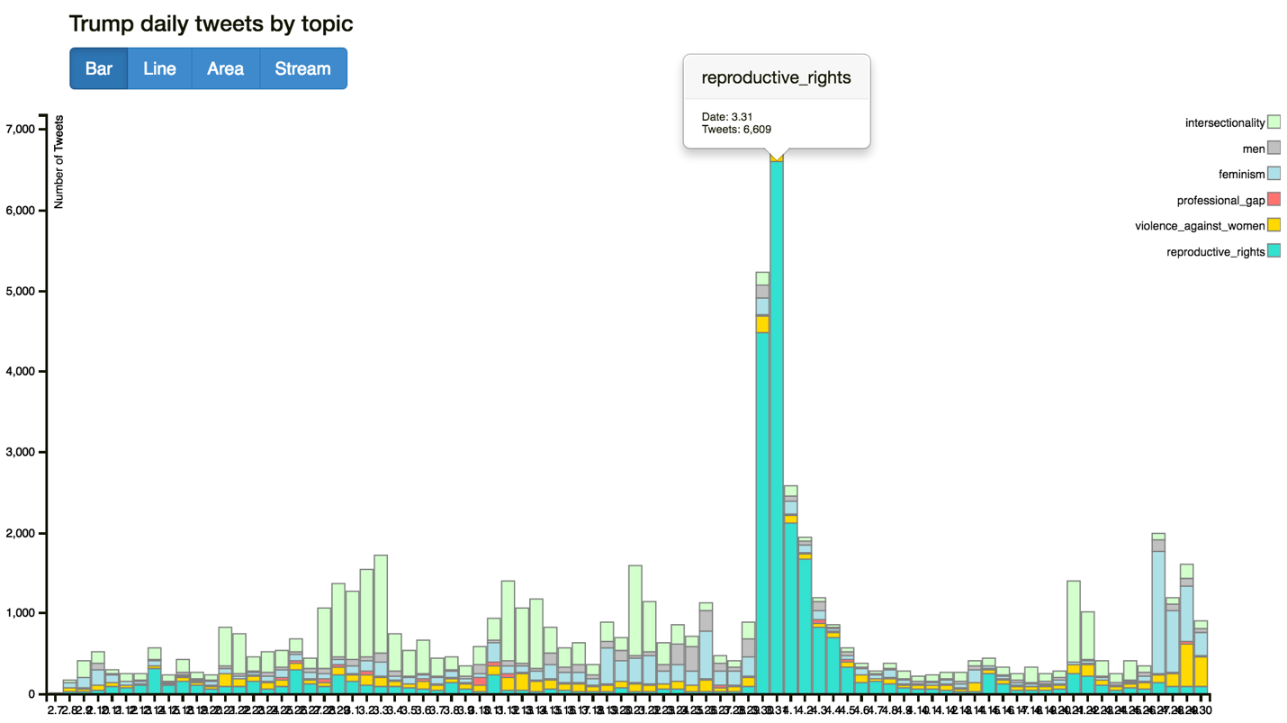

Figure 1: Large Change in Number of Tweets about Trump and Reproductive Rights: Bar Chart View

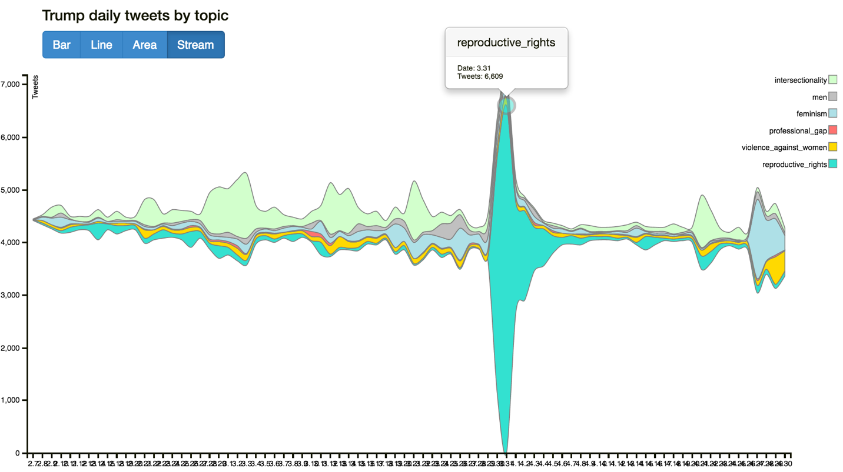

Figure 2: Large Change in Number of Tweets about Trump and Reproductive Rights: Streamgraph View

Having investigated possible explanations on the internet, we found that Trump was asked by Chris Matthews of MSNBC during a town hall on March 30th about whether he believes a woman should be punished for having an abortion. Trump responded, arguing that "there has to be some form of punishment" for women who get an abortion (Flegenheimer & Haberman, 2016). Trump later recanted his statement, issuing a statement that said the punishment for abortions should be restricted to "the doctor or any other person performing this illegal act ... not the woman" (Flegenheimer & Haberman, 2016). However, the comment still “attracted instant, bipartisan criticism — the latest in a series of high-profile episodes that have shined a light on Mr. Trump’s feeble approval ratings among women nationally” (Flegenheimer & Haberman, 2016). This statement was very controversial and caused a lot of discussion about Trump’s supposed stance on abortion. This is likely why the number of tweets about Trump and reproductive rights spiked during this time period.

We took to Twitter to see what right wing media figures had to say about Trump’s comment. They were very displeased with Trump's initial remarks, calling them "awful," "tone deaf," and "ignorant" (see Figure 3).

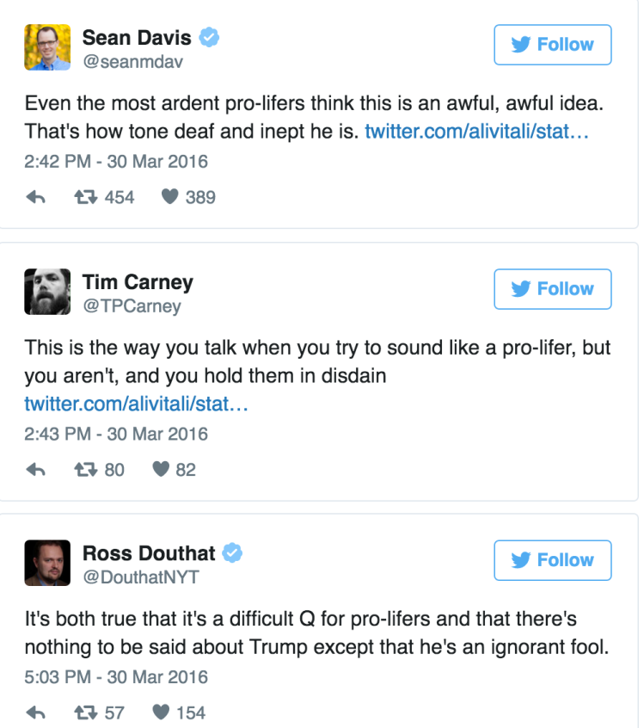

Figure 3: Twitter Reactions to Trump’s Statement about Punishing Women Who Get Abortions: Public Figures

If you look at the Google Maps [page](https://www.google.com/maps/d/u/0/edit?mid=1hWfXZ1OSb7SHFK4dorw_57Qvmto) we created, you can find tweets from this time period that talk about his statement. The tweet from Figure 4, which was posted on March 31st, reads, “@realDonaldTrump YOU ARE RIGHT!! #Trump is RIGHT about #abortionPenalties #Nukes #TrumpAlwaysRight.” Clearly this Twitter user is a Trump supporter. The tweets from Figure 5, however, come from users that do not support Trump; they read, “  
Honestly fuck Donald Trump. No woman should be punished for abortion.” and “@tedcruz ok now after trumps abortion statement.. Ban abortions/punish women who have them.. You better figure how to get that nomination!!”

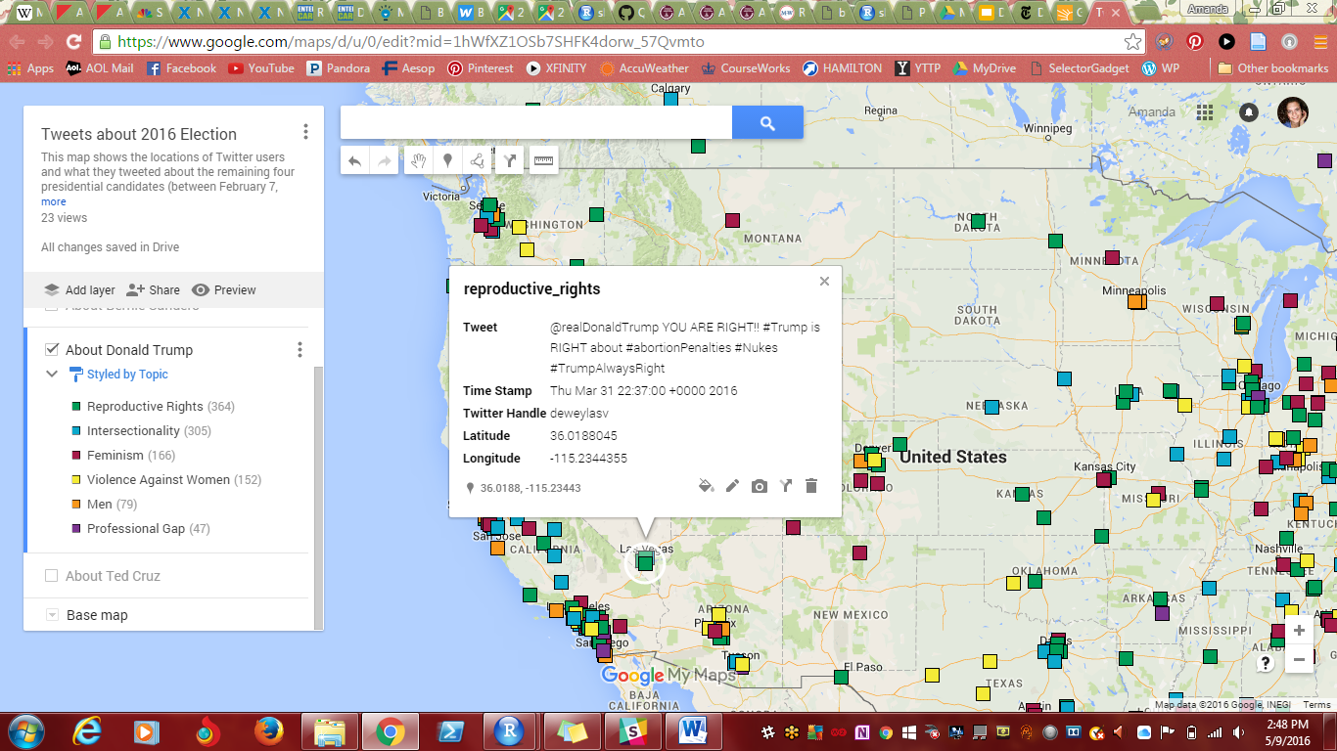

Figure 4: Twitter Reactions to Trump’s Statement about Punishing Women Who Get Abortions: Trump Supporter

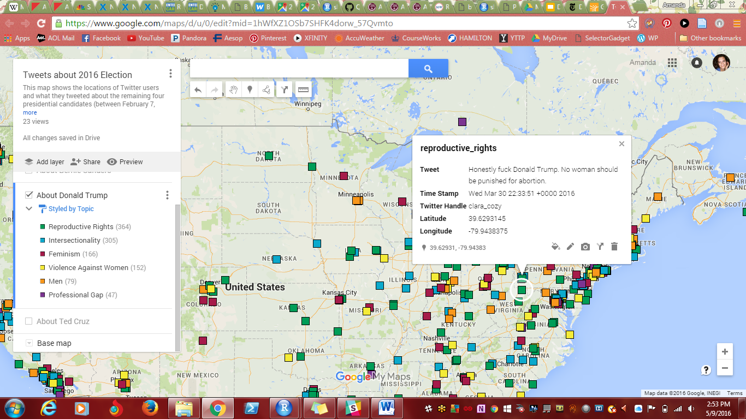

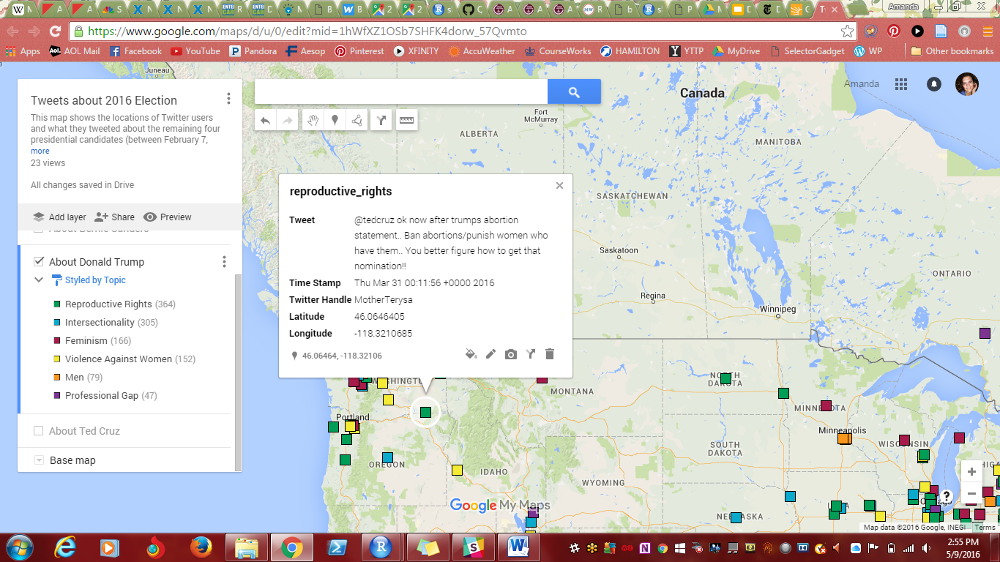

Figure 5: Twitter Reactions to Trump’s Statement about Punishing Women Who Get Abortions: Anti-Trump

Not surprisingly, other presidential candidates seized the chance to attack Trump during the campaign, especially the two candidates from Democrats (see Figure 6).

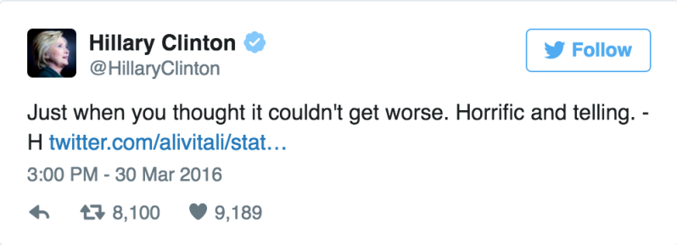

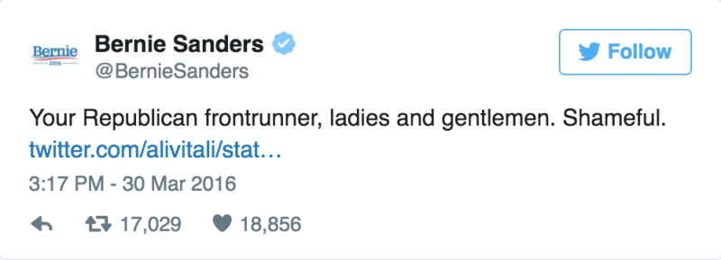

Figure 6: Twitter Reactions to Trump’s Statement about Punishing Women Who Get Abortions: Democratic Candidates

As a result of Trump’s provocative statement, tweets about Clinton and Sanders on the topic of reproductive rights also started pouring in, although the total number is not as high as Trump’s. This phenomenon is particularly obvious on March 31st, the same day that Trump’s “tweet peak” happened. The result of this interaction on Twitter is very clear in our D3 dynamic charts for Clinton and Sanders (see Figures 7 - 10).

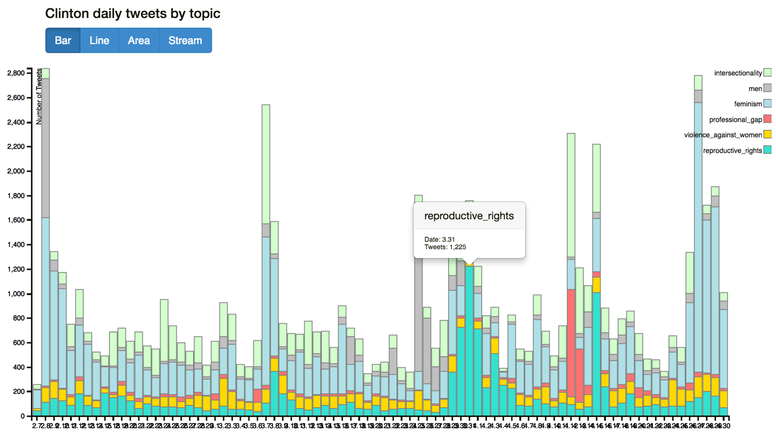

Figure 7: Large Change in Number of Tweets about Clinton and Reproductive Rights: Bar Chart View

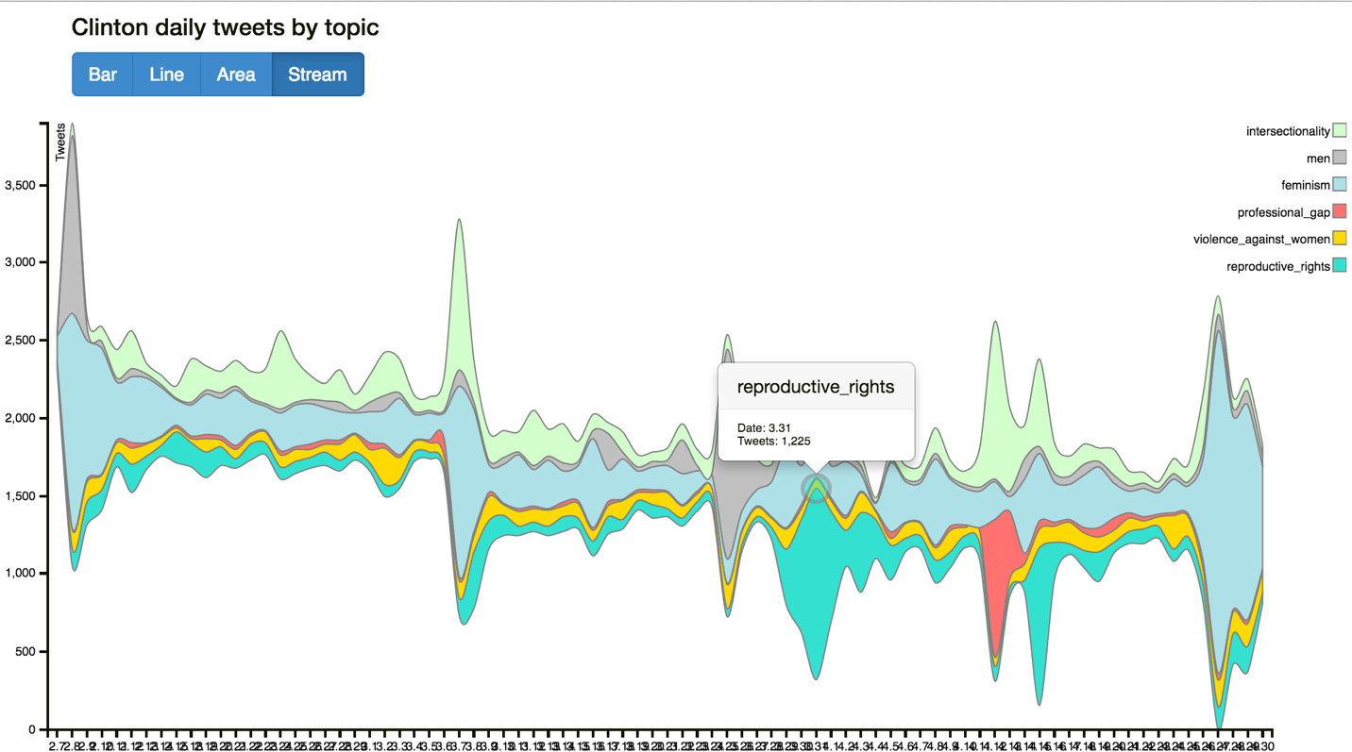

Figure 8: Large Change in Number of Tweets about Clinton and Reproductive Rights: Streamgraph View

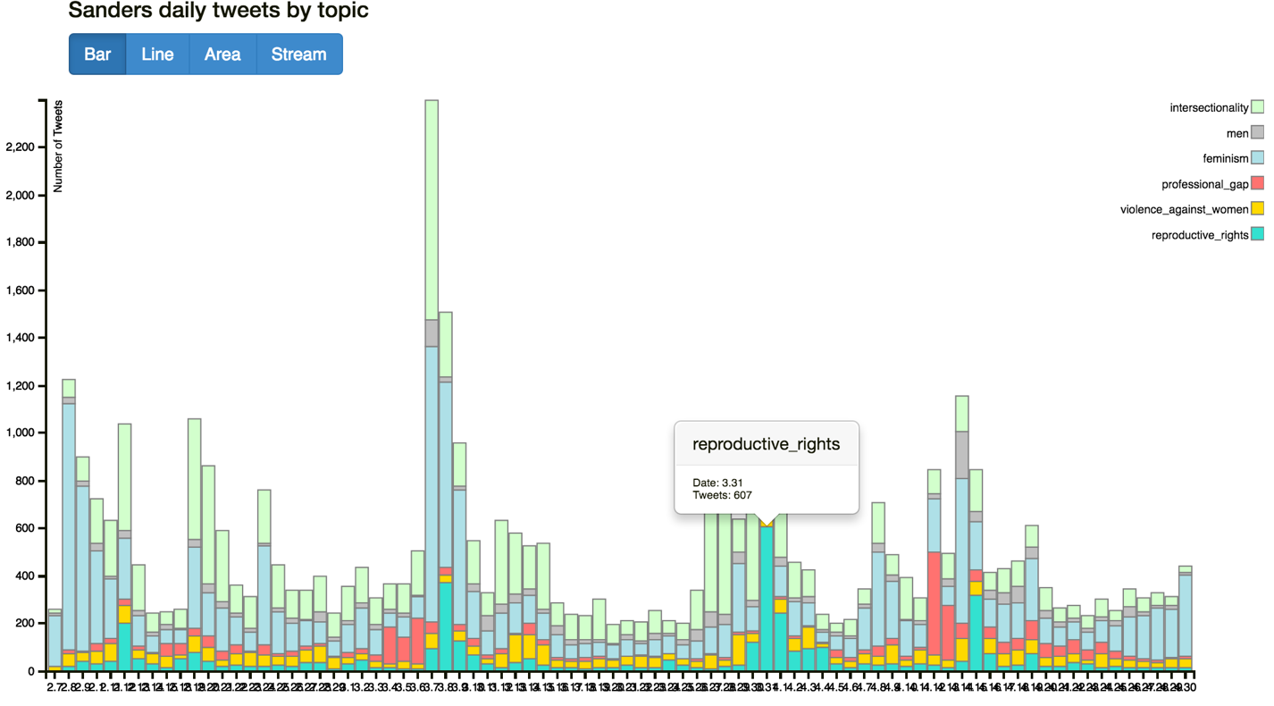

Figure 9: Large Change in Number of Tweets about Sanders and Reproductive Rights: Bar Chart View

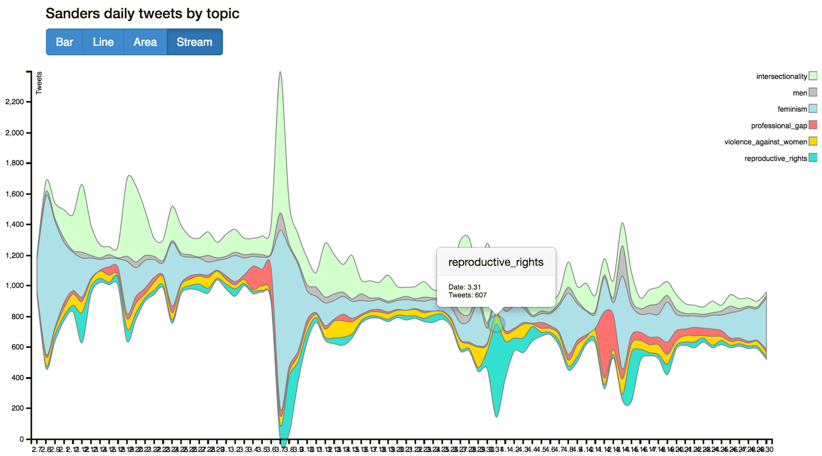

Figure 10: Large Change in Number of Tweets about Sanders and Reproductive Rights: Streamgraph View

From the plots about Clinton and Sanders, we could easily see that on March 31st, tweets about reproductive also got their peak number in the time range from February 7th to April 31st. Compared to Clinton, we could easily conclude that this sudden increase in Sanders’s tweets is mainly due to his reaction to Trump’s remark. This is because in general the tweets about this topic do not have a high median count among the four candidates – the only plausible reason of this growth is his response to Trump’s speech at that day. Although the absolute number of his tweets is not very high (607) compared to Trump’s (6609) and Clinton’s (1225), it is impressive enough for Sanders’ himself.

## H. Tweet Volume and the Professional Gap

From these D3 dynamic charts of the four candidates, another interesting pattern we noticed is the huge increase in tweets about the professional gap topic, specifically in tweets about Clinton (see Figure 11).

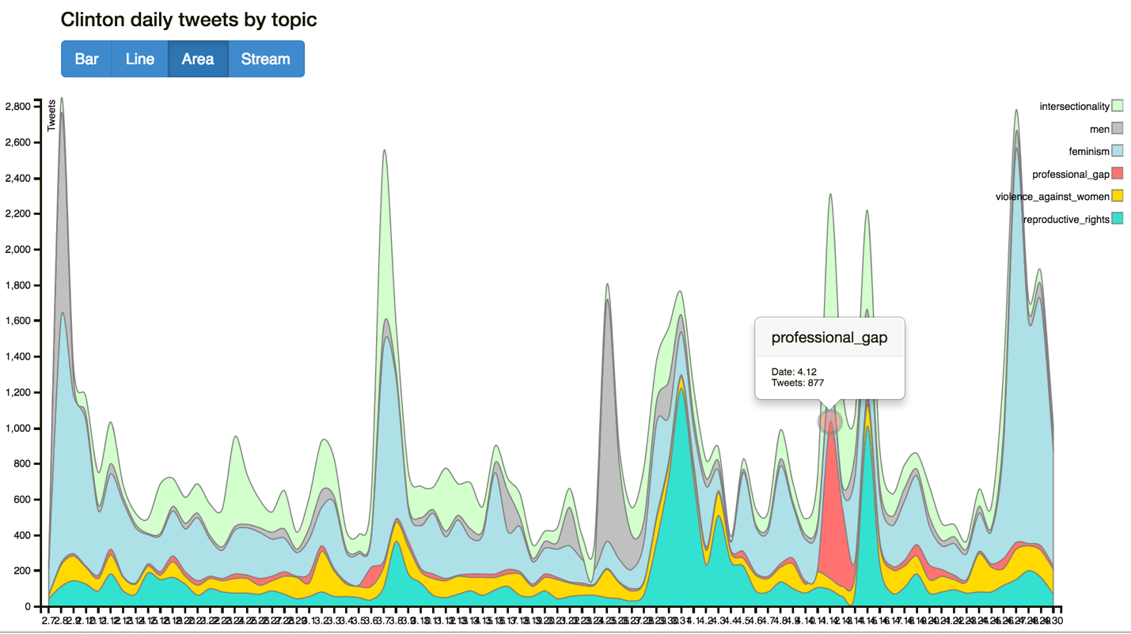

Figure 11: Large Change in Number of Tweets about Clinton and Professional Gap: Area View

The red area, which stands for the professional gap topic, takes up an incredibly large area around April 12thS. Since this issue is not a very popular topic on most other days in our sample, we wanted to explore what may be the cause for this increase in conversation. After searching for news related to Clinton and the professional gap around April 12th, we found that Clinton outlined her plan for closing the pay gap between men and women at a roundtable in Manhattan on that day. According to the Huffington Post, Clinton said the following at the event: “Last time I checked, there’s no discount for being a woman. Groceries don’t cost us less, rent doesn’t cost us less, so why should we be paid less?” (Peck, 2016). The pay issue was on the agenda because April 12th is Equal Pay Day — the day U.S. women’s earnings finally catch up with what U.S. men already earned at the end of 2015.

Since we used “equal pay” as one of our keywords for “professional gap”, of course a lots of tweets have been collected and categorized under this topic. Some social media were even saying “Hillary Clinton = A fighter for equal pay”, making Clinton become more connected to this topic. Consequently, as the frontrunner of Democrat Party, there would certainly many public figures and common people on Tweeter respond to this. Figure 12 shows one of the geo-located tweets that can be seen in our Google maps page about this topic.

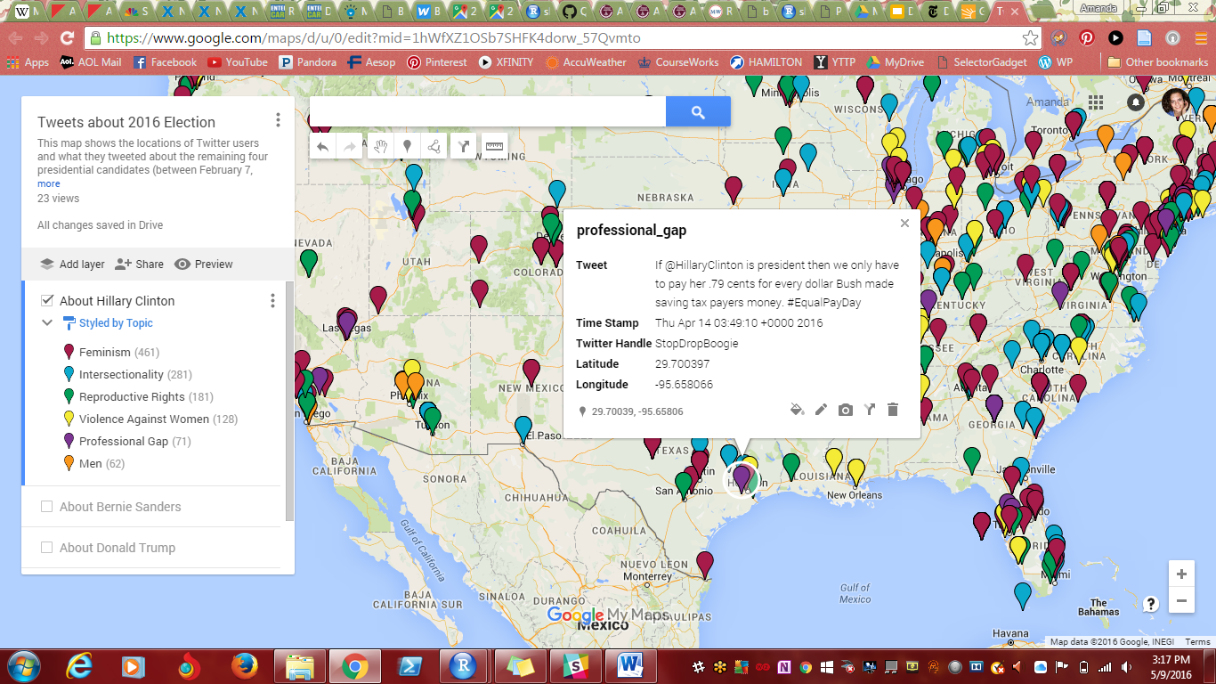

Figure 12: Twitter Reaction to Clinton’s Statement about Equal Pay

Clinton’s rival for the Democratic nomination, Sanders, tweeted a call for pay equality at the same day (see Figure 13). Sanders’ statement about equal pay caused discussion on Twitter, which is evident in our visualizations (see Figure 14).

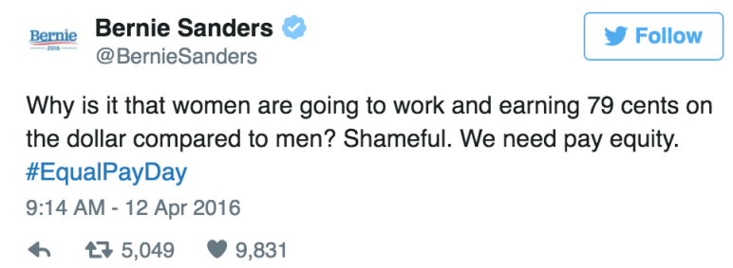

Figure 13: Twitter Reaction to Clinton’s Statement about Equal Pay: Sanders

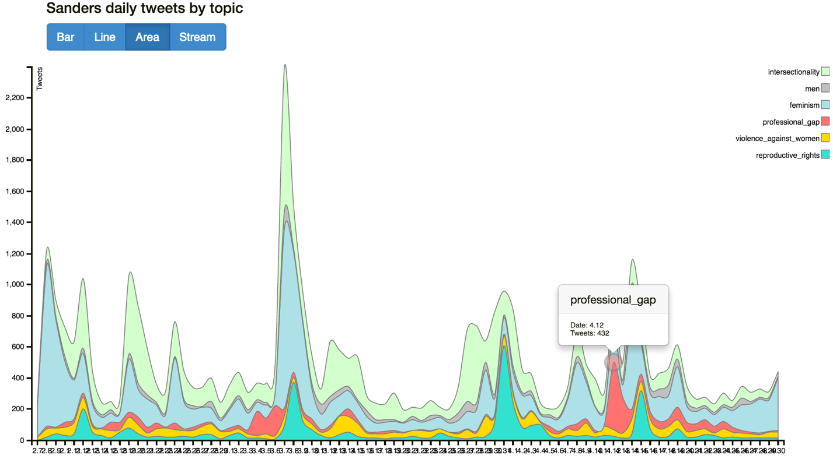

Figure 14: Change in Number of Tweets about Sanders and Professional Gap: Area View

The Republican candidates weren’t talking as much about pay equality at the time; the issue of equal pay exposes a pretty stark partisan divide (Peck, 2016). Cruz has voted against the Paycheck Fairness Act, which is a bill that would enhance legal protections for those seeking equal wages. Trump has said that women should make the same as men if they do “as good a job” (Peck, 2016). Trump has made statements supporting equal pay, but lacks policy recommendations.

Our D3 charts provide an intuitive way to compare the volume of tweets about each candidate on this topic. Cruz has a small increase in tweets about the professional gap on April 12th; it seems that, for Cruz, the greatest number of tweets about the professional gap happened on that day, too (see Figure 15). It seems that no one was talking about equal pay, or other kinds of professional gender inequality, in relation to Trump more on April 12th than any other day (see Figure 16). The overall counts for the topic in Trump’s tweets are pretty low compared to other topics.

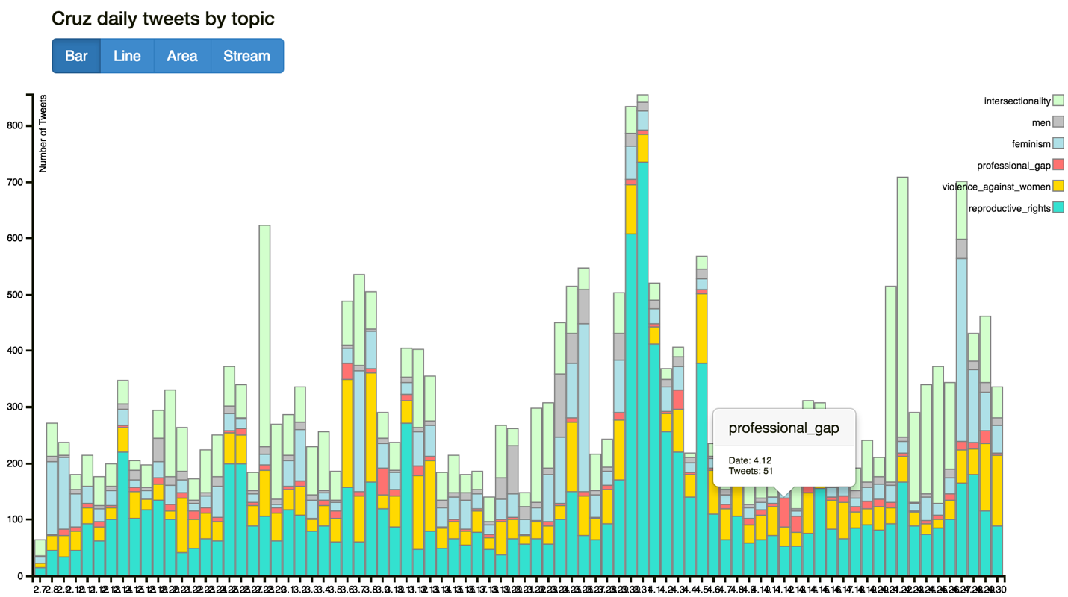

Figure 15: Change in Number of Tweets about Cruz and Professional Gap: Bar Chart View

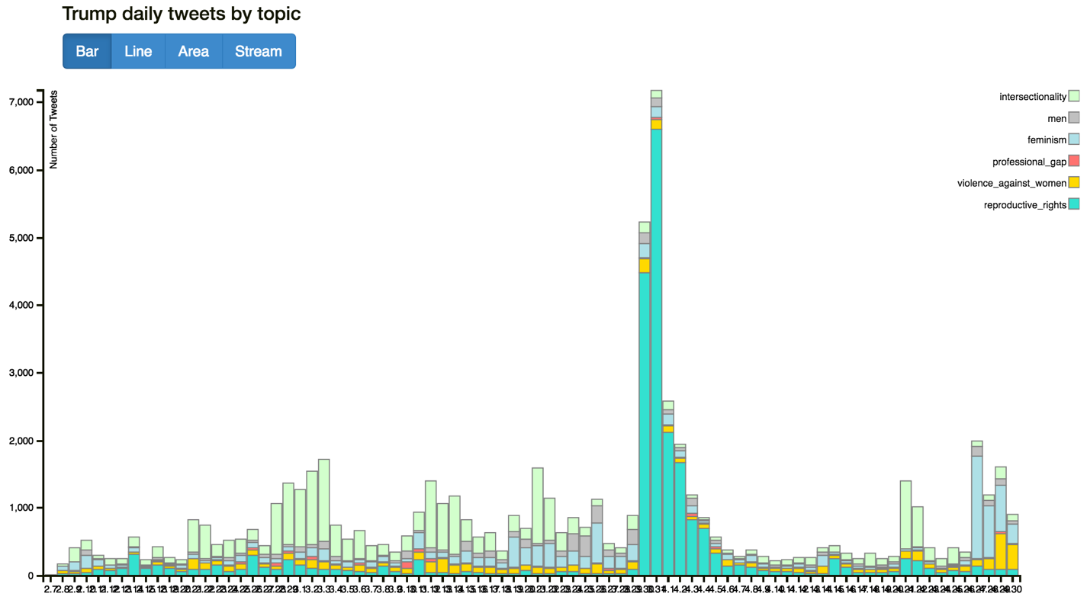

Figure 16: Change in Number of Tweets about Trump and Professional Gap: Bar Chart View

## I. Tweet Volume, Feminism and Men’s Roles

Since the hashtag *#womancard* has caught fire on an array of social media platforms, especially Twitter, after Trump made a statement about Clinton “playing the woman’s card” (Horowitz Satlin, 2016), we decided to include this term in the feminism topic for this project. Trump’s statement was sexist because it claims that Clinton is unworthy of her candidacy simply because she is a woman. He claimed that Clinton uses the “woman card” to win votes. Since late April, the “woman card” has become a major issue on social media and online discussions.

With at least 58,000 tweets by the evening of April 27th, *#womancard* was the highest trending hashtag on Twitter. After winning five primary states in a row, Trump repeated the “woman card” statement in his victory speech. For her party, Clinton won four of the five primaries on that day; in her victory speech, she responded to Trump’s statement by saying, “The other day, Mr. Trump accused me, of playing the, quote, ‘woman card.’ Well, if fighting for women's health care and paid family leave and equal pay is playing the woman card, then deal me in” (Graham, 2016).

The range of dates we included in our sample of tweets ends on April 30th, so there may be some interesting patterns related to this event that are not shown here. However, we still want to see the general trend of conversations about feminism and the “woman card.” We used two related topics: “men” (grey areas on charts) and “feminism” (pale blue areas on charts). There are some increases in the number of tweets about these topics that are visible in our plots. The clearest way to show comparisons between topics for a long time range is by looking at the D3 charts (see Figures 17 - 20).

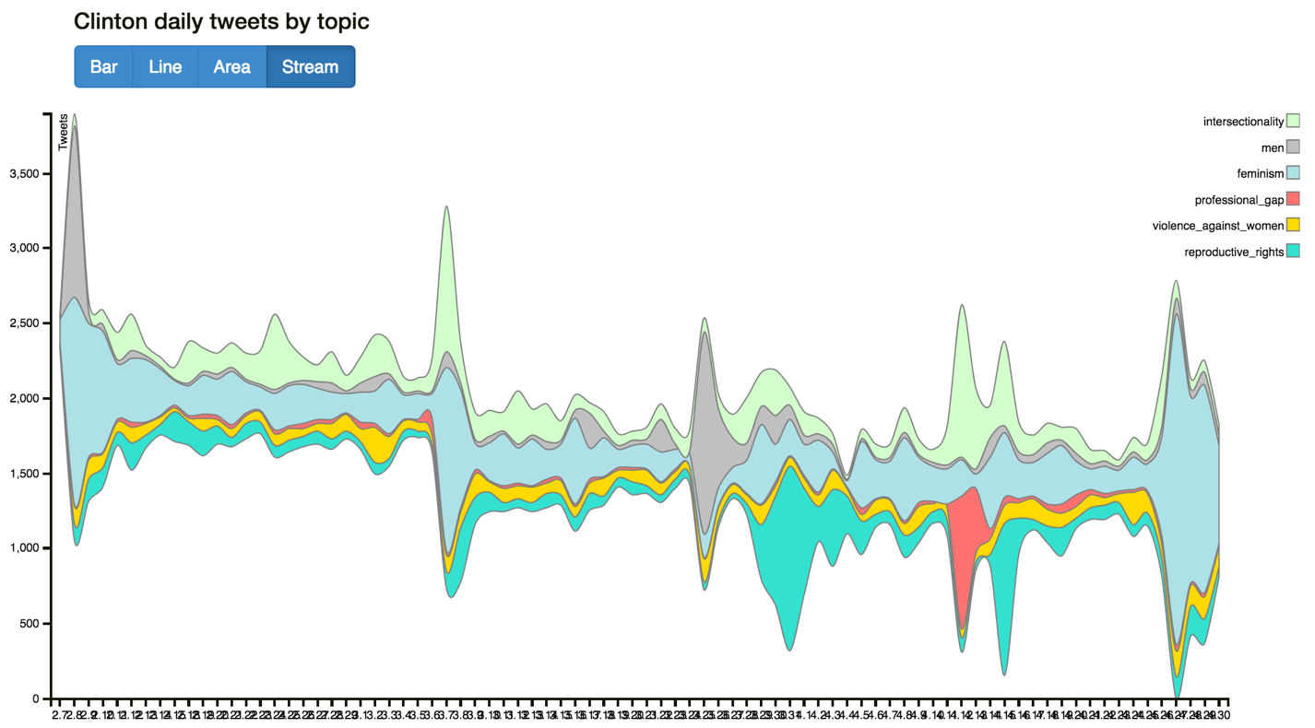

Figure 17: Change in Number of Tweets about Clinton, Feminism and Men: Streamgraph View

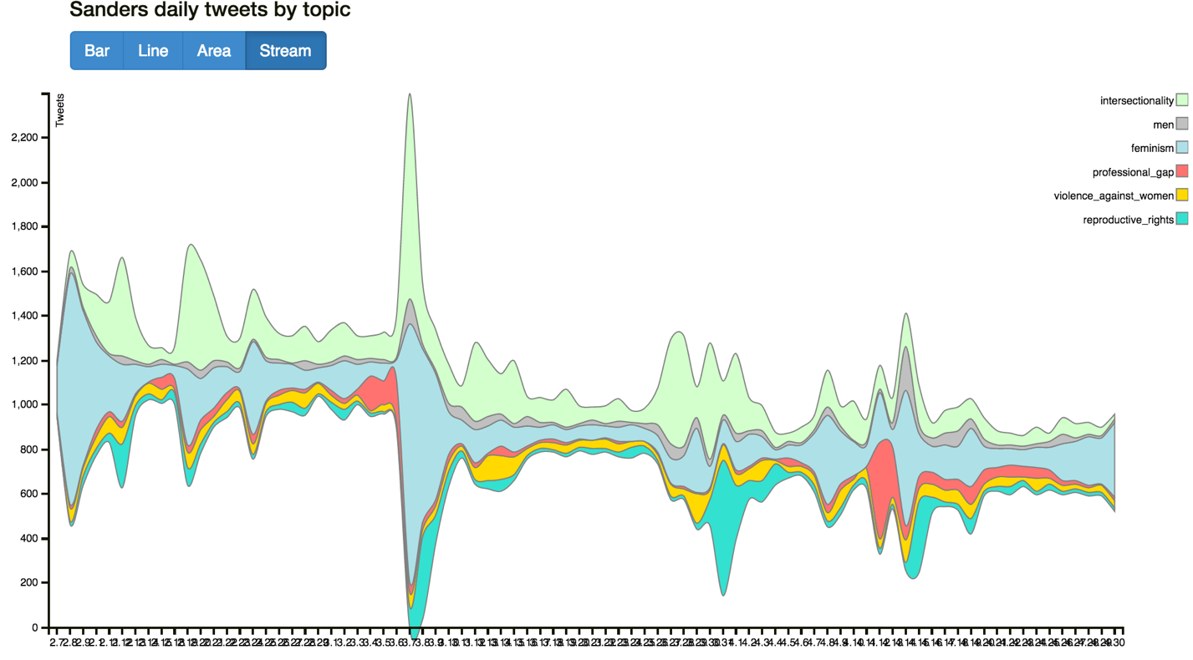

Figure 18: Change in Number of Tweets about Sanders, Feminism and Men: Streamgraph View

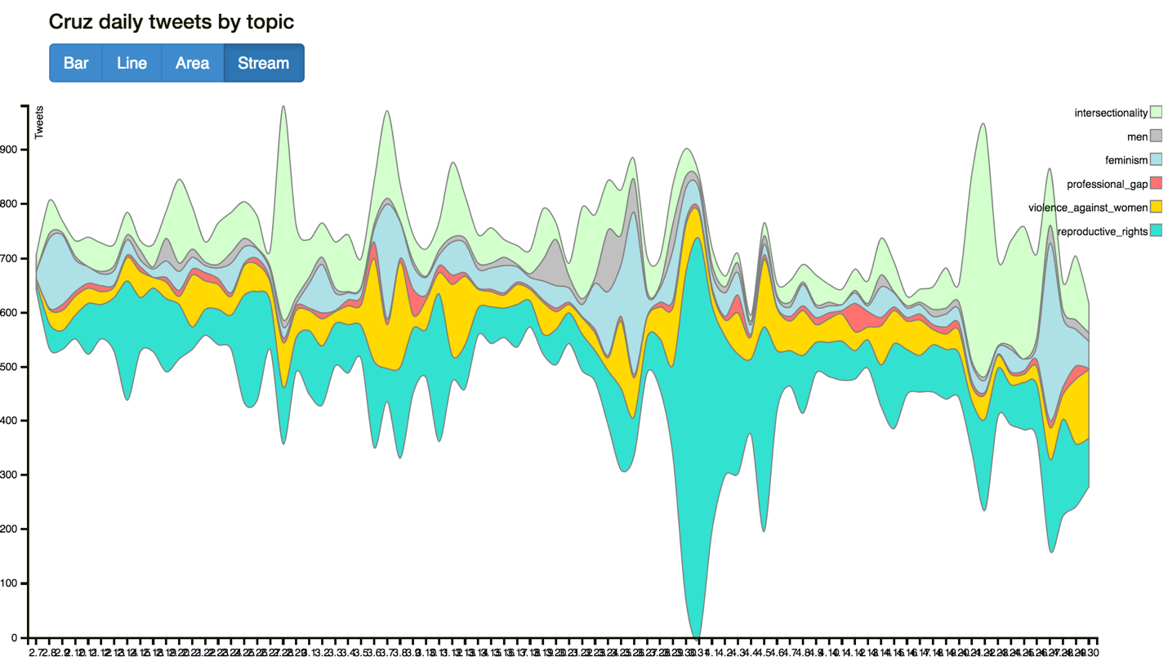

Figure 19: Change in Number of Tweets about Cruz, Feminism and Men: Streamgraph View

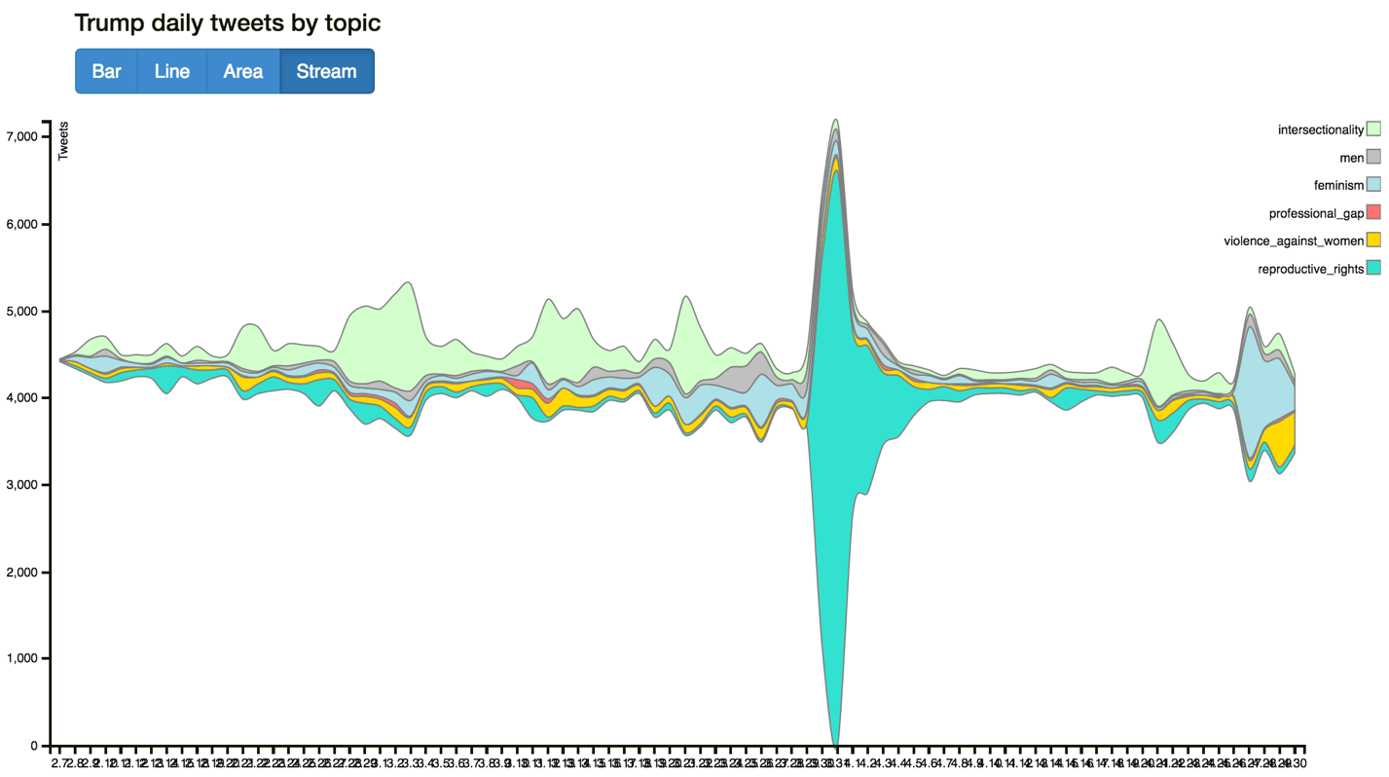

Figure 20: Change in Number of Tweets about Trump, Feminism and Men: Streamgraph View

From the above plots, apparently Clinton and Trump have the most tweets on this issue (note that the areas on Trump’s chart are not very large due to the scale of y-axis is larger than other plots), followed by Sanders, and the last is Cruz. This conclusion reflects candidates’ strong stances on these issues: Hillary Clinton is the major promoter of feminism and the woman card hashtag and Trump attacks her all the time as the enemy. As another Democrat candidate, Sanders it is not surprising that he responded to Hillary’s actions, which leads to his relatively large number of tweets on this issue. As for Cruz, he is not as keen on or involved in these women’s rights issue as much the other three candidates; consequently, the total number of tweets about him and these topics are the smallest. The tense relationship between Clinton and Trump on “woman card” is illustrated nicely in a tweet from Clinton (see Figure 21). Again, we can see evidence of discussions about feminism in the Google Maps page, as well (see Figure 22).

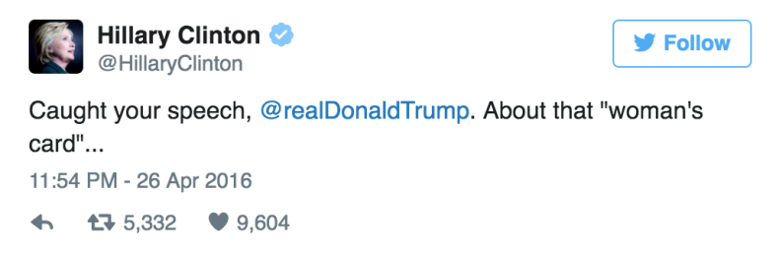 Figure 21: Twitter Reaction to “Woman Card”: Clinton

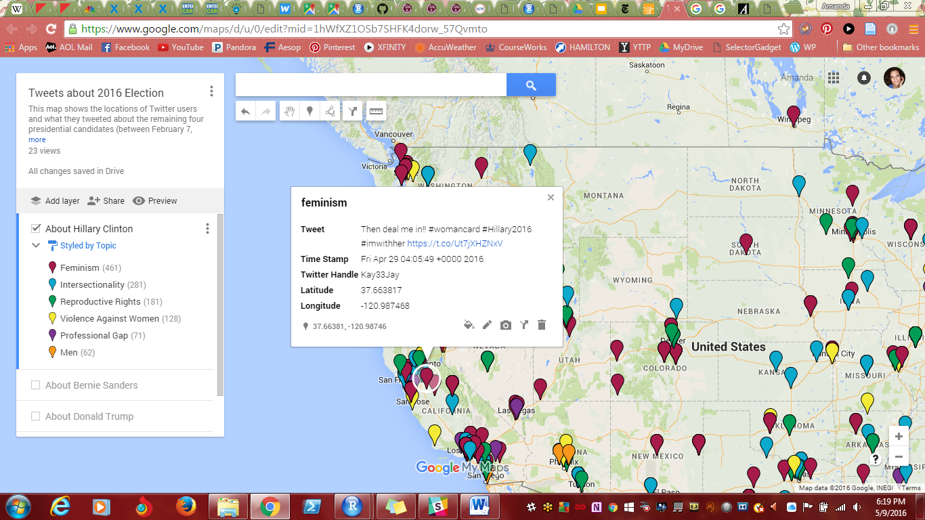

Figure 22: Twitter Reaction to “Woman Card”: Clinton Supporter

## J. Sentiment Analysis across Many Topics

While it is interesting to examine how frequently Twitter users talk about various topics, we also wanted to know how they feel about these topics in relation to the four presidential candidates. As we discussed earlier, we calculated the average sentiment score for each candidate by topic, which ranges from 0 to 9; the higher the score, the more positive the emotion in the tweets.

For each candidate, we calculated the overall mean sentiment scores per topic and how daily mean sentiment scores changed over time. Figure 23 shows how the sentiment score for each topic changed by day (again, from February 7th through April 31st) for Clinton. The topic of “professional gap” has the highest average sentiment score (about 6) for the majority of the three-month time period, whereas tweets about her and “violence against women” and “intersectionality” have the lowest scores (between 4 and 5). For the remaining topics, their scores are all about 5, which is the median of the total score range 9.

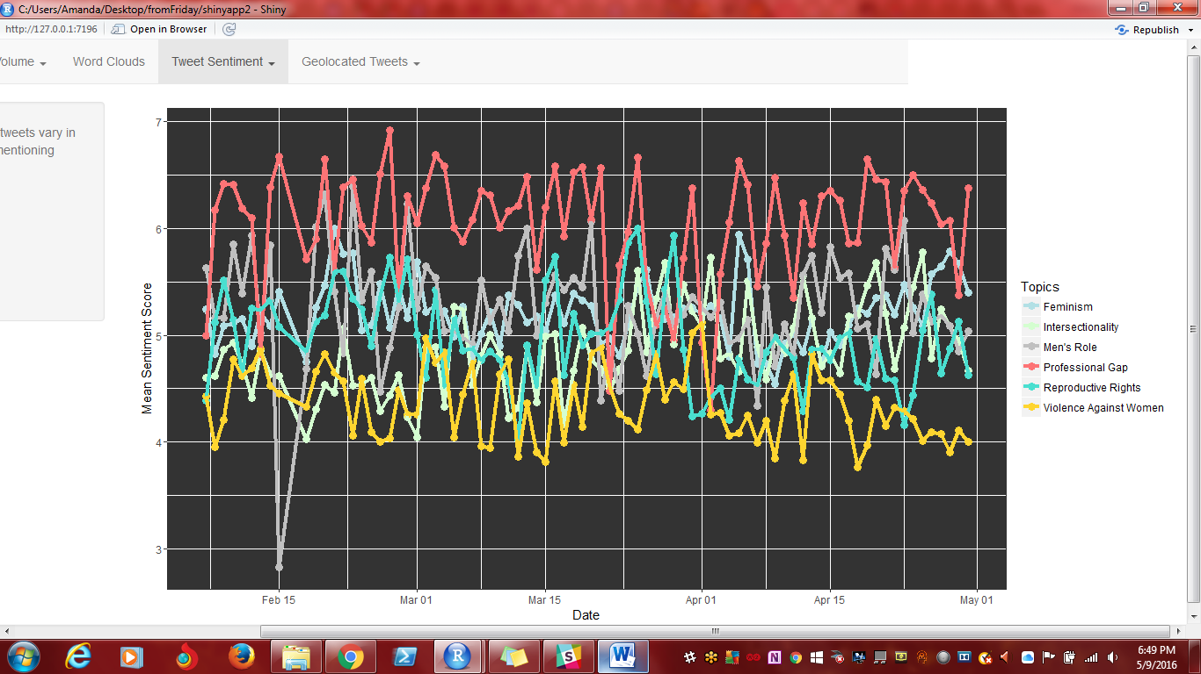

Figure 23: Daily Change in Sentiment Scores for Tweets about Clinton

We also plotted the sentiment scores on U.S. maps according to the geo-location information provided by the original tweets. Since just a very small proportion of tweets have coordinates, these observations and renderings cannot fully present Clinton’s sentiment analysis as a whole; nonetheless, we think they are interesting, so we still included them in our project. In each map, we made the continuous sentiment variables into 6 bins (serving as quantile breaks) and marked them with different colors. We chose the six bins based on the distribution of candidates’ sentiment scores. These plots go along with the above line plot: topics about “violence against women” and “intersectionality” have more negative scores and “professional gap” has mostly positive scores. In addition, generally speaking, people from the West and East are more likely to tweet their opinions on Clinton while people living in the North and Midwest tweet less. Figure 24 gives one example of these maps; the rest can be viewed in the Shiny app.

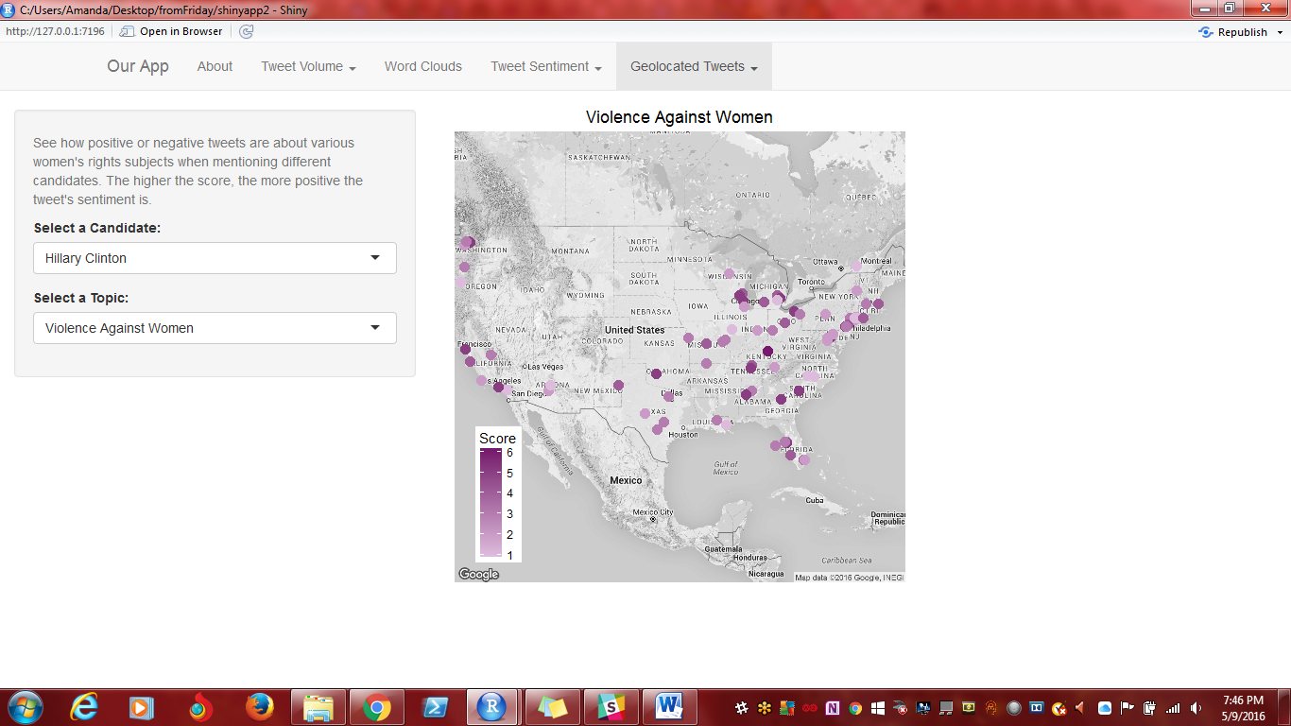Figure 24: Mapped Sentiment Scores for Clinton and Violence against Women

From Figure 25, we can see that Sanders gets the highest sentiment score for the “professional gap” category, for which he has been advocating for a very long time. The next highest score goes to the topic of “men.” For others, his scores are between 4 and 6.

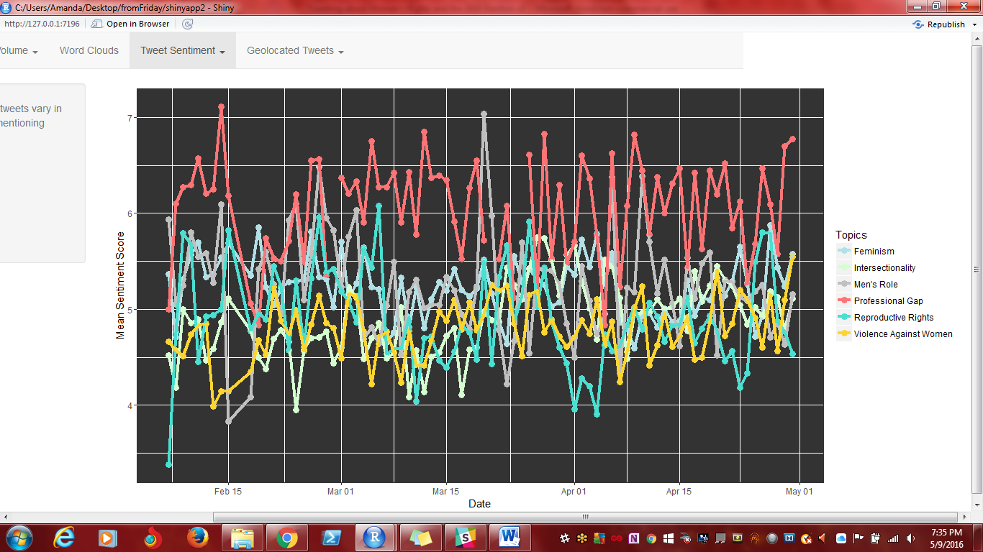

Figure 25: Daily Change in Sentiment Scores for Tweets about Sanders

We also used the same mapping procedure to plot Sanders’ scores on a U.S. map; although fewer tweets have geo-location data available, the overall score for each topic is pretty much the same as what we just concluded. “Professional gap” has the most positively-scored dots (tweets), which could mean that people have very positive attitudes about Sanders and his policies about gender equality in the professional world. For topics like “feminism” and “reproductive rights”, his scores are more negative, possibly indicating that he is not very popular in these areas or that people speak negatively about these topics in general.

In general Trump’s sentiment score is relatively low compared to the two Democrats – except for the “professional gap” category, most of his scores are around 5. The feedback on his “men” issue is particularly low – from mid-February to mid-March his score is below 4, once even below 3 (see Figure 26). Many users on Twitter say that Trump is misogynistic, which is one of the words we used to capture tweets about “men.”

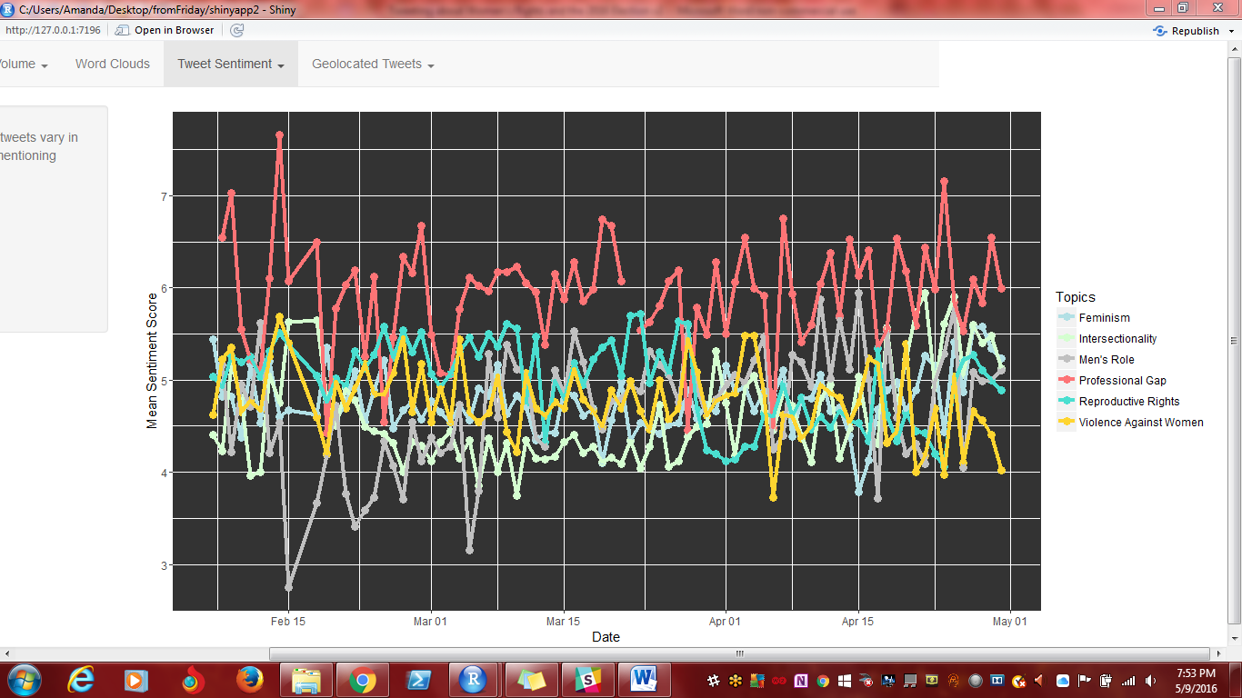

Figure 26: Daily Change in Sentiment Scores for Tweets about Trump

Like Trump, Cruz also gets the highest sentiment score in the “professional gap” category and the lowest score on the issue of “men” (see Figure 27). For other topics, his average score is a little bit lower than Trump’s: they are mostly scattered between 4 and 5. Similar to Trump, Cruz has pretty negative sentiment scores for the “men” topic; many people say that Cruz is sexist and misogynistic because of his social opinions policies. Figure 28 shows some of the tweets found on our Google Maps page that support this idea, for both Trump and Cruz.

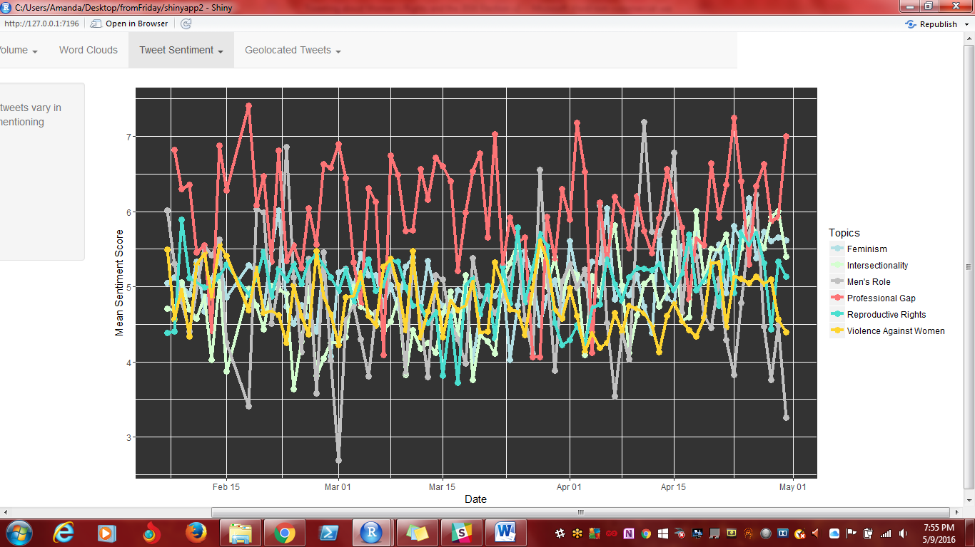

Figure 27: Daily Change in Sentiment Scores for Tweets about Cruz

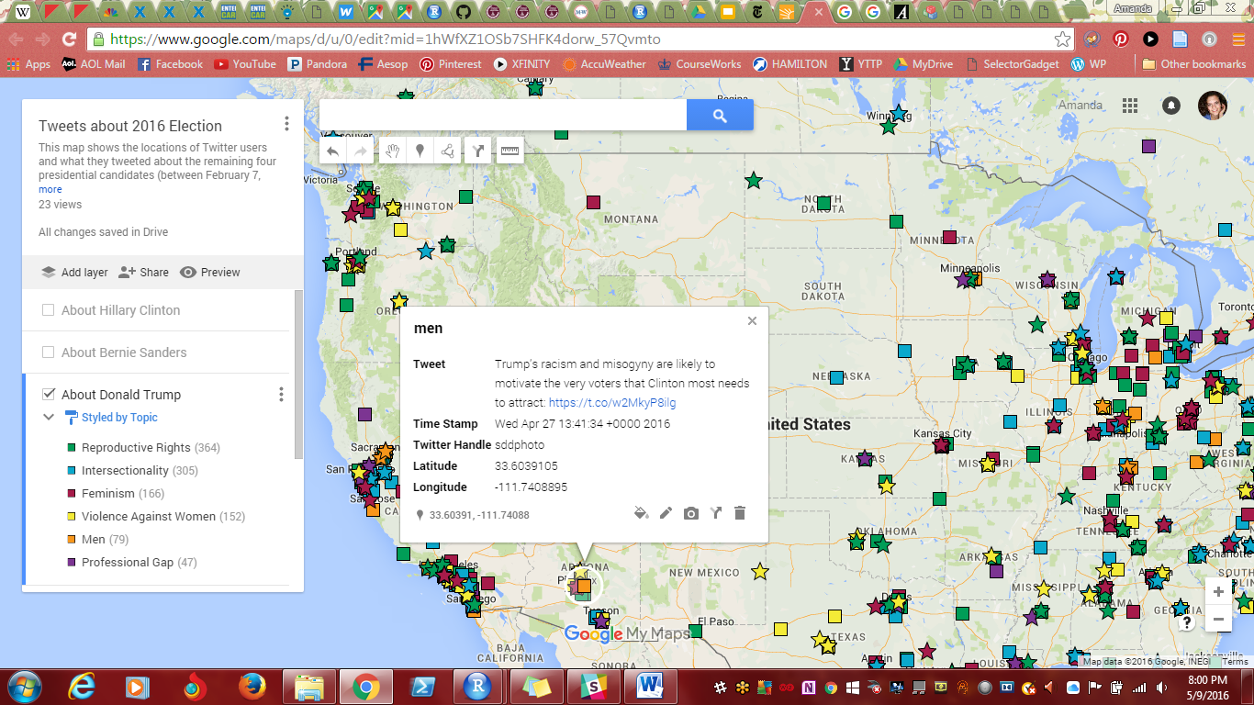

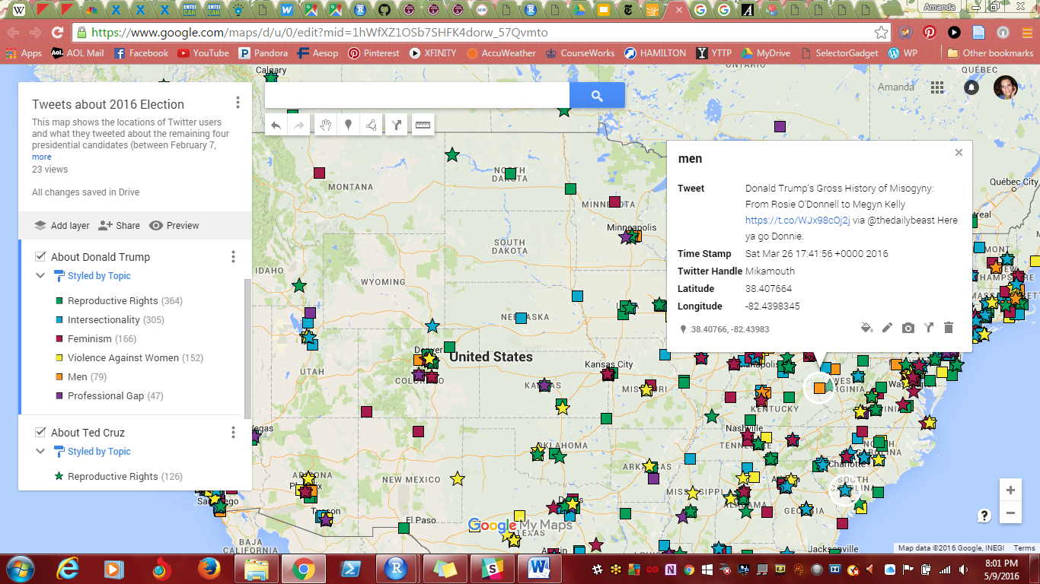

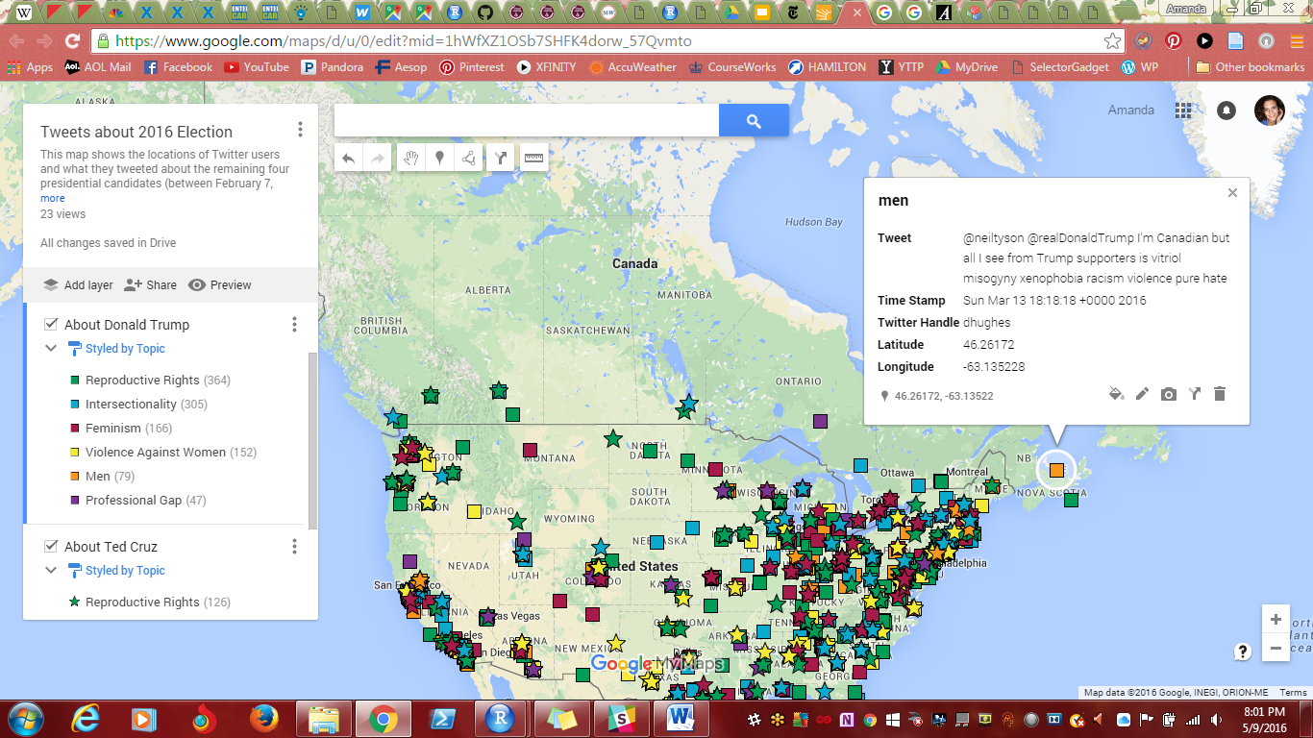

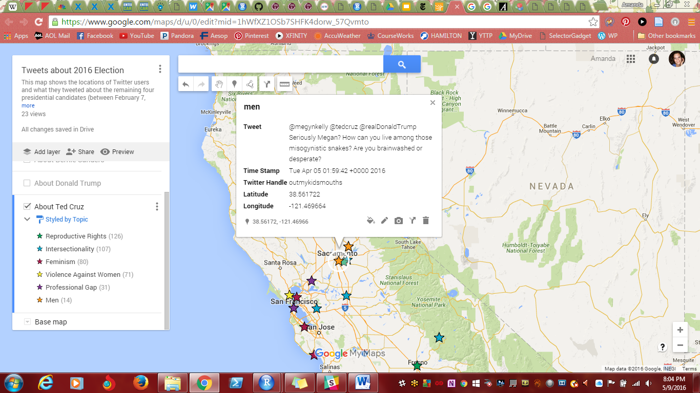

Figure 28: Tweets about Trump, Cruz, and “Men” Topic

# IV. Limitations and Future Directions

Like we mentioned before, there is so much to be investigated regarding how people on Twitter talk about the presidential candidates and women’s rights that we could not cover it all. Of the patterns we observed and discussed in this paper, most of them could be explained by real-life events, such as comments that candidates made during their campaigns. While our visualizations seem to do a good job of depicting current events that changed discussions on Twitter, we encountered some limitations in creating the data visualizations.

First, some of the terms we used to create the regex dictionaries for the six topics picked up unrelated words. For example, we used the hashtag *#leanin* in the dictionary for the “professional gap” category because “lean in” is a phrase associated with women’s equality in the work place. Unfortunately, the regex function picked up other words that had “leanin” inside them, such as “cleaning” and “leaning.” Another example is with the word “rape,” which we put in the “violence against women” category; the word “grape” was picked up, which was unintended. This may have skewed the analyses a bit. In the future, we could tweak the regex functions a bit more to make them more fool-proof.

Additionally, when doing the sentiment analyses of the words in each candidate’s corpus of tweets, we did not account for emoticons. Emoticons are used often to express emotion and would have been very useful to include in the sentiment analysis portions of this project. However, we do not have the capabilities to identify and analyze emoticons at the present. This is another area that can be explored in future iterations of this project.

Overall, we feel that the data visualizations we created represent how Twitter users talk about the various candidates and women’s rights. They seem to accurately mirror real-world events that may have caused changes in the way people tweeted about these topics. Overall, the Democratic candidates were more supportive of women’s rights compared to the Republican candidates. Twitter users had very passionate opinions about all of the candidates. We hope you will explore these visualizations for yourself in our [Shiny app](https://arg2211.shinyapps.io/DataVizFinal/).

# V. References

American Psychological Association, Task Force on the Sexualization of Girls. (2007). *Report of the APA Task Force on the Sexualization of Girls*. Retrieved from http://www.apa.org/pi/women/programs/girls/report-full.pdf

Bernie 2016. (2015). Fighting for women’s rights. Retrieved from https://berniesanders.com/issues/fighting-for-womens-rights/

Center for Reproductive Rights. (2015). The power of law for every women. Retrieved from http://www.reproductiverights.org/sites/crr.civicactions.net/files/documents/2015%20Annual%20Report%20Final%20PDF.pdf

Chan, C. (2014). 6 hashtags we can use to advance gender equality. Retrieved from http://mashable.com/2014/10/01/women-hashtags/#tBo2Woy.puqc

Crawford, M., & Unger, R. (2004). *Women and Gender: A Feminist Psychology* (4th ed.). New York, NY: McGraw-Hill.

Cruz for President. (2015). Life, marriage, and family. Retrieved from https://www.tedcruz.org/issues/life-marriage-and-family/

Donald J. Trump for President, Inc. (2015). Issues. Retrieved from https://www.donaldjtrump.com/issues/

Flegenheimer, M. & Haberman, M. (2016). Donald Trump, abortion foe, eyes ‘punishment’ for women, then recants. *The New York Times*. Retrieved from http://www.nytimes.com/2016/03/31/us/politics/donald-trump-abortion.html?_r=1

Google Developers. (2016). Google Maps JavaScript API tutorials. Retrieved from https://developers.google.com/maps/documentation/javascript/tutorials/

Graham, D. (2016). Why Trump might regret playing 'the woman card' against Clinton. *The Atlantic*. Retrieved from http://www.theatlantic.com/politics/archive/2016/04/trump-hillary-clinton-woman-card/480129/

Hillary for America. (2015). Women’s rights and opportunity. Retrieved from https://www.hillaryclinton.com/issues/womens-rights-and-opportunity/

Horowitz Satlin, A. (2016). Women everywhere wonder where their ‘woman card’ is after Trump’s Clinton diss. *The Huffington Post*. Retrieved from http://www.huffingtonpost.com/entry/hillary-clinton-woman-card-responses-donald-trump_us_57207f22e4b0f309baef3bf4

Howard, L. (2015). 6 Twitter hashtags to browse in honor of women’s equality day. Retrieved from http://www.bustle.com/articles/106486-6-twitter-hashtags-to-browse-in-honor-of-womens-equality-day

Hunt, K. (2015). The feminist hashtags that matter in 2015. Retrieved from http://www.elleuk.com/now-trending/hashtivism-the-feminist-hashtags-that-are-ruling-2015

Long, B. (2014). Feminism 101: Learning the lingo. Retrieved from http://bellebrita.com/2014/08/feminism-101-learning-lingo/

Kronovet, D. (2016) twitter_research. Retrieved from https://github.com/kronosapiens/twitter_research

McPherson, S. (2014). Empowering women and girls, on hashtag at a time. Retrieved from http://www.forbes.com/sites/susanmcpherson/2014/05/27/empowering-women-and-girls-one-hashtag-at-a-time/#339a4f385990

National Organization for Women. (n.d.). Issues. Retrieved from http://now.org/issues/

Noman, N. (2015). The 9 most important feminist hashtags of 2015 so far. Retrieved from http://mic.com/articles/117608/the-9-most-important-feminist-hashtags-of-2015-so-far#.sSUjfmYFk

Northup, N. (2013). Huffington Post: The fight for women's reproductive rights can't just be about winning or losing the abortion war. Retrieved from http://www.reproductiverights.org/press-room/huffington-post-fight-womens-reproductive-rights-winning-losing-abortion-war-Roe

Peck, E. (2016). Hillary Clinton: ‘There’s No Discount For Being A Woman, So Why Should We Be Paid Less?’ *The Huffington Post*. Retrieved from http://www.huffingtonpost.com/entry/hillary-clinton-pay-gap_us_570d10e1e4b01422324a264b

Plank, E. (2014). The 12 most powerful feminist hashtags of 2014. Retrieved from http://mic.com/articles/104970/the-12-most-important-feminist-hashtags-of-2014#.WFwDZ2jlO

Pressman Fuentes, S. (2014). Top 18 issues challenging women today. Retrieved from http://shriverreport.org/top-18-issues-challenging-women-today/

Vidal, A. (2014). 'Intersectional feminism': What the hell is it? (And why you should care). Retrieved from http://www.telegraph.co.uk/women/womens-life/10572435/Intersectional-feminism.-What-the-hell-is-it-And-why-you-should-care.html

Warriner, A. B., Kuperman, V., & Brysbaert, M. (2013). Norms of valence, arousal, and dominance for 13,915 English lemmas. Retrieved from http://www.uvm.edu/~pdodds/research/papers/files/2013/warriner2013a.pdf

WHO Media Centre. (2016). Violence against women. Retrieved from http://www.who.int/mediacentre/factsheets/fs239/en/

World Economic Forum. (2015). The global gender gap report 2015. Retrieved from http://reports.weforum.org/global-gender-gap-report-2015/